Identify your hunger type
Having a better understanding of the hunger you're experiencing will allow you to better honour / manage it.
There are 3 types of hunger you may experience (which can also overlap);
- "True" (physical) hunger
- Taste hunger
- Emotional hunger
Actual physical hunger
This appears gradually when you have not eaten for a few hours. You may feel low in energy, irritable and have an empty gnawing feeling in your stomach.
Helpful strategy: Eat regularly (as discussed above in diet structure). Ensure you are eating enough to feel at least 70% full at mealtimes (see hunger scale). Aim to slow down and eat mindfully at meals. This can increase enjoyment and overall satisfaction of meals.

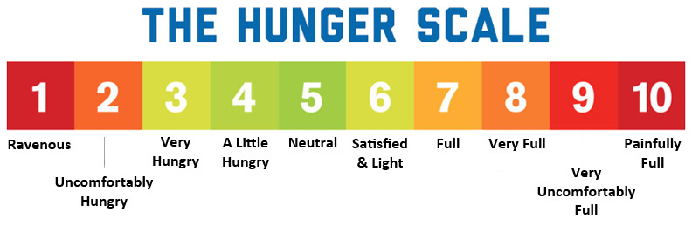
Best tips to manage;
- Eating regularly
- Eating to a comfortable level of fullness
- Having regular protein and fibre servings
- Having a healthy sleep schedule

Taste hunger
This occurs when you have a specific food raving that is satisfied by having a small portion of that food. It could be that you have not eaten a certain food in a while, or your diet may have become too repetitive and or restrictive.
Helpful strategies: Think about what textures or flavours your diet is missing and include a larger variety in your diet. You may also need to work on slowly reintroducing foods that you feel are “off limits” one at a time. This is something we will be working on throughout our process and journey.
Best tips to manage;
- Honouring the craving (having a serving of the food you’re craving that you are comfortable with)
- Restricting restriction
- Having plenty of variety in your diet with food choices, cooking methods, tastes and textures.

Emotional hunger
This is very common and comes on very urgently. You use food to soothe or ignore these difficult emotions however they often lead to feelings of guilt after consuming foods.
Helpful strategies: Firstly, don’t beat yourself up, emotional eating is completely normal.
To deal with emotional hunger the first step is to identify the emotion causing it.
I often use the acronym HALT with my clients which stands for:
- Hungry
- Angry
- Lonely
- Tired
This can be helpful when you feel the urge to act in an abusive way and to stop, take a conscious pause, notice how you are feeling and try to identify what emotion is coming up and ask yourself what course of action is best at this time? Keep asking why.
Once you have figured out the emotion what we then need to do is come up with alternative solutions to dealing with these emotions. If hunger isn’t the problem, food will rarely be the solution. Make a list of other non-food coping strategies e.g. journaling, a hug, petting a dog, going outside and getting a daily dose of nature, improving sleep quality and practicing self-talk, all of which we will discuss throughout the following weeks.
Best tips to manage;
- Pausing and taking a breath.
- Identify what you're experiencing.
- Understand the emotion is temporary and you don't have to act rashly in this instance.

