Balance new client worksheet

Please complete the below worksheet and submit it via email on the day of your check-in.

      - What does being healthy mean to you?

2.Which one habit do you think you can start with first in terms of your food?
(Perhaps think of your barriers and use these to identify a habit to get started).

The 10 habits:
- Eat 3-4 meals per day
- Have 1 lean source of protein per meal (i.e. non-breaded/not fried)
- Aim for ½ your plate vegetables
- Take an omega 3 oil & vitamin D supplement at breakfast
- Drink at least 3 litres of water per day (if not on a fluid restriction)
- During each meal eat until 80% full
- Drop any liquid calories (lattes, sugary drinks, alcohol)
- Notice your “trigger foods)
- Get active in daily life- walk more
- Starting back to weights 1 day a week
- Sleep at least 8 hours per night

- How confident are you that you can do this for the next 2 weeks out of 10 (10 very confident)?

- How/ when and where will you complete this habit?

e.g. My goal is to cook my dinner from scratch. Every Sunday I will plan my meals for the week and go grocery shopping to buy the ingredients. I will meal prep on a Sunday and Wednesday night.

- Finding your deeper why (the 5 whys)
Why do you want to change?

Why do you want to achieve that?

And why is that important?

And why will that make a difference?

And why will that matter?

Example from a previous client….

- Why do I want to lose fat? Because I want to fit into a smaller size of jeans.
- And why does that matter? Because when I’m wearing smaller jeans, I think I’ll look better.
- Why do I want to look better? Because when I look good, I feel good about myself.
- Why do I want to feel good about myself? Because when I feel good about myself, I’m more confident.
- Why do I want to be more assertive and confident? Because when I’m more confident my relationships are better and overall quality of life is better.

d
c
b
a

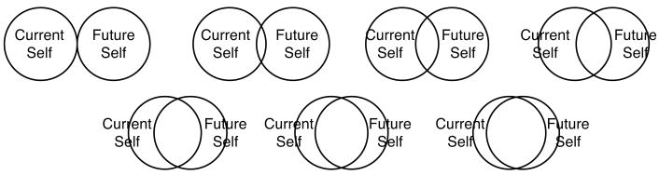

g
f
e

- Next I want you to think about how far away your present self is to your future self (using the letters above). Next I want you to answer, what does my future self-look like and who are they, what behaviours do they have and daily habits to they practice?
(your future self is based on your ultimate goal)

- Your Mindset- please indicate your response to the following statements.

You can learn new things, but you can't really change your basic intelligence.
- Disagree | - Somewhat  disagree | - Somewhat  agree | - Agree

- People are born with a certain amount of talent and there is little you can do to change it.
- Disagree | - Somewhat  disagree | - Somewhat  agree | - Agree

- I embrace challenge
- Disagree | - Somewhat  disagree | - Somewhat  agree | - Agree

- I have willpower and persevere
- Disagree | - Somewhat  disagree | - Somewhat  agree | - Agree

- How do you react when people give you feedback on your performance (e.g. work, relationship, exercise, sports, finance etc)?

- How do you react when you fail at something? E.g. weight loss/ exercise

