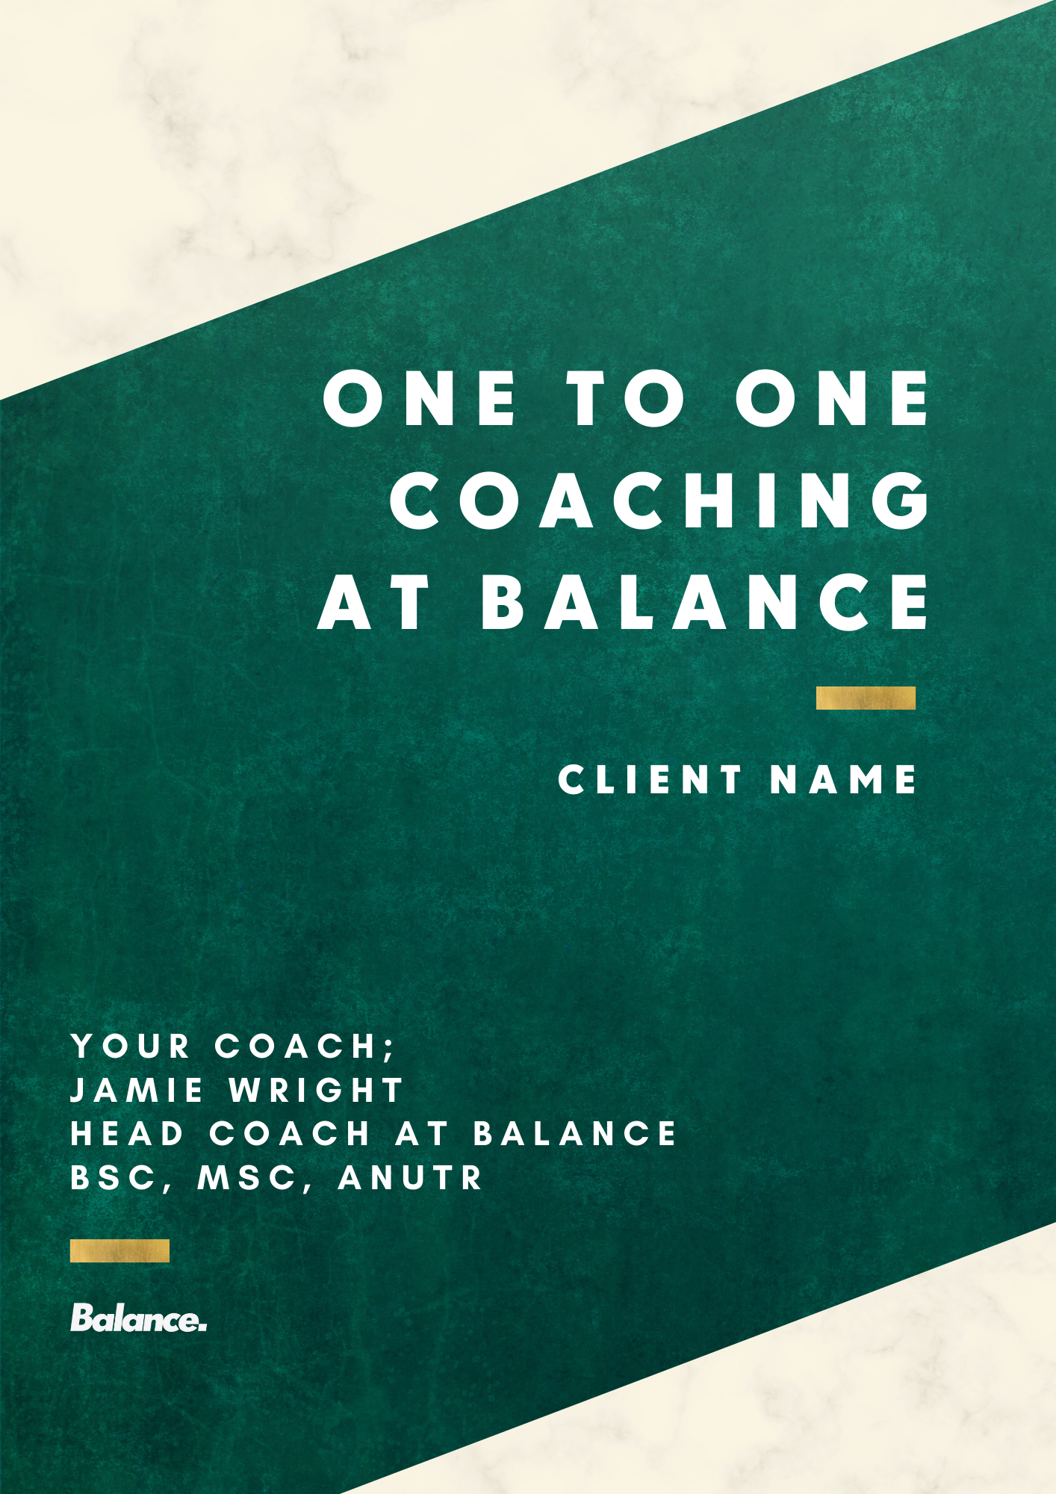
WELCOME TO BALANCE

We’re here to support you in achieving your happiest, healthiest self
At the heart of our practice is a team of qualified, compassionate and extremely hard-working coaches who have been in your shoes and wish nothing more than for you to succeed.
As a team, our coaching philosophy revolves around five core themes;
- Empathy
- Empowerment
- Education
- Understanding
- Progress
You can see the rest of our team here so you’re well acquainted with everyone.
Our role in the time you’re working with us is to get you to the stage whereby you won’t need us anymore; Balance isn’t forever, we’re here to set you up to move forward on your own, empowered, educated and confident, for the rest of your life.
We want this to be a continuous process of progress, learning, challenge and development.
We encourage you to communicate with us (via email, Whatsapp or voicenotes) when you need to and we implore you to reach for us when you need support as well as share with us the times in which you’ve succeeded (or had, what we call, “lightbulb moments” – learning moments essentially).
You can check in with your respective coach here.
And all other reading resources (as well as recipe books and other useful extras) can be found here and we have a library of free resources available to everyone that you may want to explore too!
To round up this introduction, the purpose of this plan is not just to take you forward today, but to be a resource you can always return to.
We’re so excited to be working with you and we’re even more incredibly excited to see your success and be a part of this journey alongside you Jamie.
Any part of the journey you’d like to share on social media (tagging either your coach or @balance_ie) would be more than appreciated also and help us spread the word of a truly client centred form of coaching that genuinely cares about the outcome (please don’t feel any pressure to do so though!).
Here’s to the next few months and to your journey with Balance Jamie!

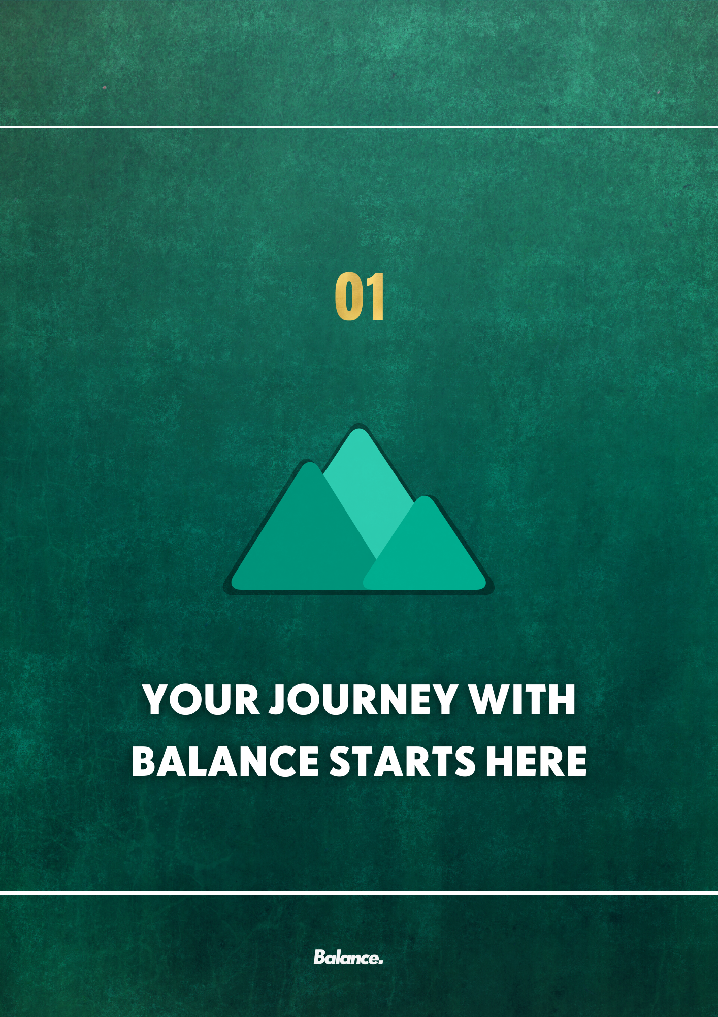

HEALTH GOES FAR BEYOND WEIGHT

What does it mean to be healthy?
Just before we dive straight into your initial recommendations Jamie, I want you to consider one thing for me…what does ‘being healthy’ mean to you? It’s not a trick question, I just want you to explore and consider what springs to mind.

I want to reassure you that your health & wellbeing is my main priority, so to ensure that I’m doing this in line with your expectations Jamie, I want you to have a think about this question and let me know your thoughts in this worksheet (which you can view by following the link)

My goal is not just about tweaking your nutrition and specific food choices. It’s also about fostering a healthy relationship between you and food, your body, your self-talk as well as other things like managing stress and prioritising sleep.

There is much more to life than simply the food we eat and the body you are living in and we need to make sure we zoom out and look at the bigger picture.
You want to be eating enough to sustain yourself and support your exercise and lifestyle, without going overboard. This includes eating a diverse, plant-centric diet with plenty of quality protein sources and a range of nutrients but…. that’s not all.
Your diet should benefit you mentally too. This means satisfying cravings and supporting your cognition and decision making. It shouldn’t induce any obsessive tendencies. Rather, it should leave you feeling empowered. I want you to feel in control of your diet; not feeling that your diet controls you.
Social health is important too. The healthiest diet for you will take your lifestyle into account. You should be flexible and adaptable to navigate social situations in a way that supports your goals, whilst living your life at the same time. You should feel able to eat out with friends, drink alcohol in moderation or indulge on occasion if you wish.
My main goal for you is to ensure the way you approach nutrition is to uplift your physical, emotional and social health. As I mentioned your health & wellbeing is my number one priority so I want you to feel like you can trust me, speak to me at any time and communicate it to me if you feel like your health is not moving forward at any stage throughout the process.

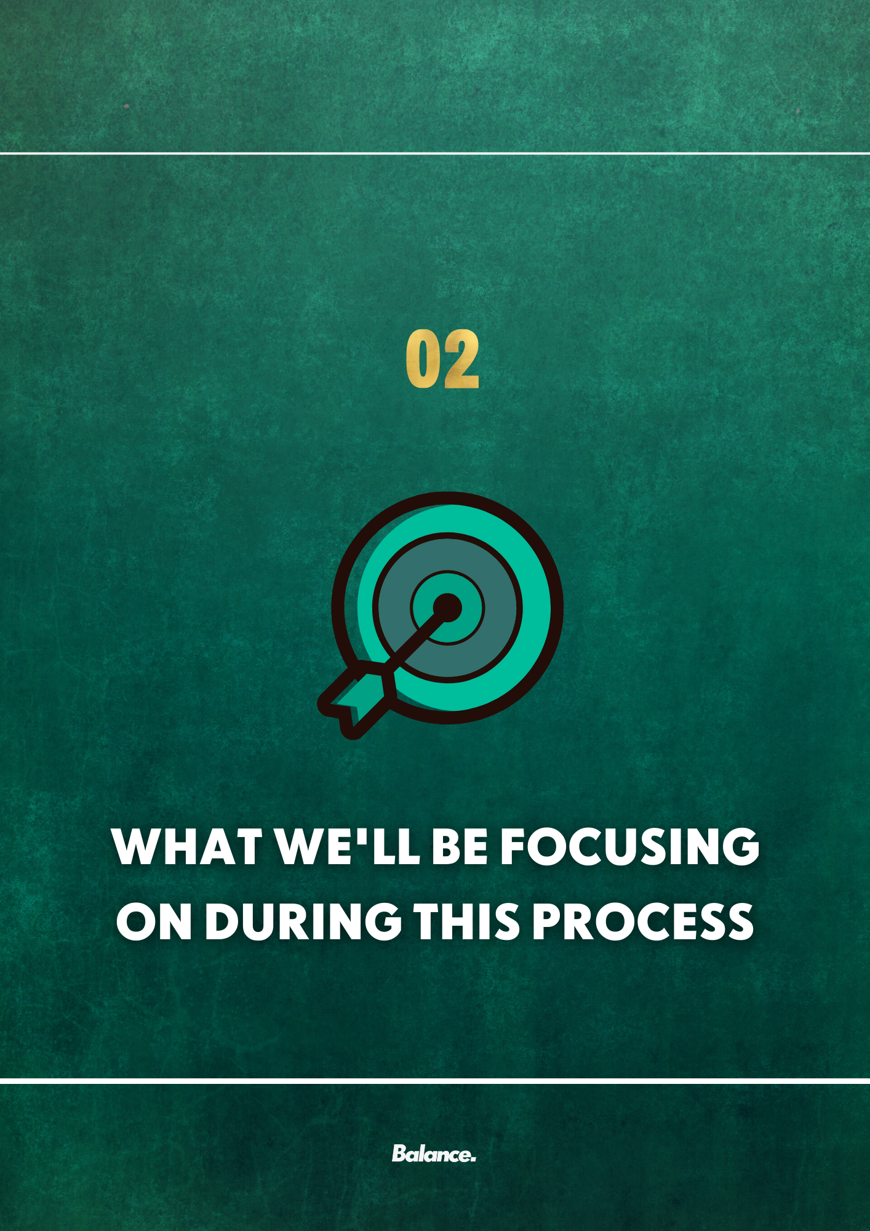
SMALL STEPS TOWARDS BIG CHANGE

Focus on taking a small step, not climbing the whole mountain
One of the main reasons people’s journeys towards a healthier self fall to the wayside is that they either set themselves to lofty or unrealistic a goal or they becoming transfixed upon the finish line of an incredibly challenging goal.
Here at Balance, we like to practice zooming in when it comes to our goals; not getting so caught up in you a month from now, six months from now, a year from now or more. Rather, we ask those we work with to focus on today. To focus on the healthiest, happiest version of themselves today and how they can work towards that (within their given circumstances).
My primary focuses for you Jamie during our time together will be;
- Exploring various approaches to nutrition we can use to help improve your relationship with food

- Assess other factors which might be affecting your relationship with food such as body image & self-worth

- Focusing on setting small achievable targets and scaling them with your comfort and experience levels.

- Improving your performance in general life (helping you achieve the best possible version of yourself) and focusing on sustainable change
One of my favourite exercises to use for goal setting is the SMART principle (which you can read more of here). This principle helps us to design and plan goals which are detailed and focused as opposed to goals which are vague, ambiguous and more likely to falter.
As part of our work together Jamie I’d like for you to complete this worksheet for me over the next two to three days and send it back to me.
SMART goals are simply goals which are;
- Specific
- Measurable
- Achievable
- Realistic
- Timebound
Overleaf you’ll find a blank SMART principle goal setting worksheet which you can print out or you can follow this link for the word document.
INITIAL | Write the goal you have in mind
GOAL
S | What do you want to accomplish? Who needs to be included? When do you want to do this? Why is this a goal?
SPECIFIC
M | How can you measure progress and know if you’ve successfully met your goal?
MEASURABLE
A | Do you have the skills required to achieve the goal? If not, can you obtain them? What is the motivation for this goal? Is the amount of effort required on par with what the goal will achieve?
ACHIEVABLE
R | Why am I setting this goal now? Is it aligned with overall objectives?
RELEVANT
T | What’s the deadline and is it realistic?
TIME-BOUND
SMART | Review what you have written, and craft a new goal statement based on what the answers to the questions above have revealed
GOAL

Focus on taking a small step, not climbing the whole mountain
In terms of our day to day focus Jamie I’d like for you to focus on;
- Having a consistent and self-serving routine which uplifts and empowers (for both during the week and weekend) which you’ll build with our routine planner.
- Using a simple and effective method of determining meal sizes whilst developing a dynamic meal structure to best serve you, your goals and your circumstances.
- Addressing negative opinions, comments, thoughts with an objective perspective rooted in reflection on your own personal success and effort to make change
- Moving away from a calorie focus and making it a healthy behaviour focused dietary change
- Introducing simple, research-based sports nutrition strategies
- Adopting a more lenient way of eating; gradually encouraging exposure to foods once believed to be “bad” and beginning to shift our perspective on them slowly and at a rate which you’re comfortable with Jamie
- Aim for 3 - 6 portions of fruit and vegetables (in any format; soup, shakes, within other foods etc.) a day (we’ll scale this upwards as your comfort level dictates).
- Improving your relationship with food and yourself. Allowing full flexibility with foods and maintaining an open dialogue with me throughout the process to focus on positively reaffirming the changes we are aiming to make.

The 2-minute rule
One of the things we like to preach here at Balance is making life easy for yourself. As mentioned, Jamie, one of the reasons we fail when it comes to implementing our goals, making behaviour changes or introducing new habits is that we set our sights far too high.
The 2-minute rule (pioneered by David Allen and championed by James Clear, author of Atomic Habits) is simply; “When you start a new habit, it should take less than two minutes to do.” In fact, you’ll find that nearly any habit can be scaled down into a two-minute version:
- “Read before bed each night” becomes “Read one page.”
- “Do thirty minutes of yoga” becomes “Take out my yoga mat.”
- “Run three miles” becomes “Lace my running shoes.”
The idea is to make your habits as easy as possible to start Jamie.

Try this with your own new habits and send me a few examples with your first check-in.

A new habit should not feel like a challenge. The actions that follow can be challenging, but the first two minutes should be easy. What you want is a “gateway habit” that naturally leads you down a more productive path.

You may not be able to automate the whole process, but if you can make the first action mindless and make it easy to start, the rest will follow.
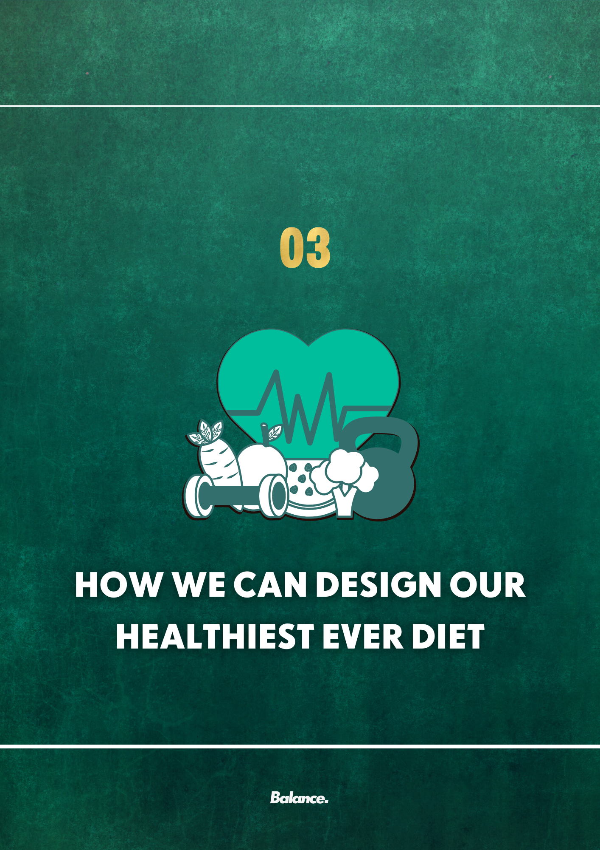

THE FACTS ON FOOD AND OUR BODY

Clarity is important; it helps us dismantle unhealthy and unhelpful beliefs
Before we dive into how our body and food work, I’d like to mention Jamie that, although we want to work on your relationship with food and self, we don’t want to lose sight of your goal around body composition change.
Rather, it’s important for us to understand why you want to make the change and where that is coming from.
The driver behind change determines the healthiness of that ambition.
For example, if you wish to lose weight to feel more physically comfortable, achieve a better state of fitness and look to improve your wellbeing for you, then that’s what we’d describe as an internally driven ambition.
In real life that may sound a lot like someone exclaiming “I want to take control of my health and become the healthiest version of myself”.
An internally driven ambition for change is one which is most likely to succeed (as these changes are better aligned with our identity, values and beliefs).
In most circumstances, internally driven change leads to an overall better state of health.
On the other hand, externally driven change is a lot less likely to succeed and is often associated with more desperate and or unhealthy strategies to achieve a certain goal.
One example of this would be if you are pushing yourself to develop more muscle in a bid to appease someone else, to be of greater perceived worth or believe you’ll “fit in” to a certain group and you were considering using drugs to facilitate this, overtraining or disregarding other responsibilities / social interaction.
Another example I’d like to share (as it comes up for us quite frequently in practice) is that, for the vast majority of us Jamie who set out to lose / change our weight, we do so in hopes of improving the way we look (an external driver).
What we tend to fail to realise is that changing the way we look to receive external validation does not necessarily change the way that we feel about ourselves.
This is very important to understand. When you reach your ‘goal weight’ what tends to happen is the benchmark then moves i.e., you need to lose more weight. To this point you’ve relied on a number going down and external validation (compliments most usually) and, if you’ve never considered why you may want to do this for yourself, you may continue to chase that external validation with progressively more desperate, unhealthy and even possibly dangerous methods of weight loss.
The point here Jamie is that, in this scenario, we’d need to work on how you feel about your body as well as reinforcing that weight is not the sole dictator of success.
Whilst initial motivation may carry the person forward for a time, eventually this will dissipate and the individual will be left questioning themselves, their identity, values and beliefs because they’ve spent so much energy and time being someone they are not.
This is not to say that we cannot change, of course we can change, but if we’re relying on the validation of others to cement that change then we’re placing the success and happiness of our life in the hands of another person (who may themselves not even realize or care that you’re aiming to make these changes).
So, at Balance we do work a bit differently. We aren’t here to tell you what is right or wrong; we are here to support you, explore the ambitions for a change and let you determine whether that ambition is to be changed, tweaked or pursued.
The reason why we discuss this in such depth Jamie is because this next section of your plan is going to discuss physical change and how that works.
There is a growing community of people proclaiming any form of physical change to either be a waste of time or evidence that you do not love / care for your body. I refute both of these claims. We can succeed with change (whether it be physical or mental or both) and you can both love your body and wish to change it at the same time.
Whether you wish to change your body or maintain it whilst having another health-related goal in mind, I personally believe Jamie that providing you with clear, informed and evidence-based information is important.
Providing honest, clear and true information (with which you can choose what to do with) is not an indictment as to who are today, reading this now; it’s a form of respect that we trust you to use that information to further your journey to your healthiest, happiest self.
So, in this section of the plan we’ll be covering;
- Energy intake
- How to build a healthy / nutritious meal
- A “meal builder”
- A meal planning document

Energy intake and the principle of energy balance.
One of the first things I’d like to mention Jamie is, although we want to work on your relationship with food and self first, we don’t want to lose sight of your goal around body composition change. Rather, I’d like for you to spend some time considering what we discussed on the previous few pages of your plan and consider if the change you’re making is internally or externally driven. If it is externally driven then I’d like for you to spend some time, not necessarily changing the goal, but shifting your sense of perspective on it.
Begin with shaping your language back towards favouring yourself. So, instead of “x will find me more attractive if I lose y weight” try instead reaffirming “I’ll feel more comfortable in my body and confident in who I am if I lose x weight”.
Understanding what pushes us towards a goal and ultimately where our feelings and emotions arise from will help us begin to understand and express more self-compassion for moments where we do doubt ourselves.
I know that you’re already well aware of the basics surrounding weight change Jamie, but it’s something I’d like to quickly cover again regardless (just a brief refresher and good to know we’re on the same page!).
Our body is a wonderfully complex, miraculous machine combining both the worlds of biology and engineering. Like any machine, we need energy to function and, our energy, comes in the form of food.
The energy we take in and can use from the foods we eat are called calories.
They aren’t tiny little monsters that hide in our food with the intention of making us gain weight (no matter what fad dieters will con you into believing). No, they are simply what we need to carry out our body’s functions and to build, repair, recreate and tear down existing structures (like muscle, organs, bone etc.).
On the surface, and far beyond the millions of cellular reactions that calories fuel, our food intake plays an important role in our body’s size; ultimately, it dictates whether it stays the same, grows or shrinks.
- If you eat more calories than you burn you will gain weight.
- If you burn more calories than you eat you will lose weight.
- If you eat the same number of calories that you burn your weight will not change

There are two sides to weight change; how many calories we take in vs. how many we ultimately expend. One of the things which confuses many people (even frustrates) is how erratic weight change can be day to day.

Tangible change (be it growing new muscle, losing significant amounts of body fat or even improving bone density) takes time.

“But why did my weight move 2kg over night!?”

Well, we also have intangible weight considerations too; the amount of water in your body, your stored carbohydrate (called glycogen which is used for energy) and food which is still passing through our gut / gastrointestinal system.

Day to day fluctuations are expected and they can be extremely erratic at times (for women even more so when you consider the impact of the menstrual cycle on weight change)
That’s why we’d prefer if you do not use the scales Jamie as a marker of progress or as a measure of defining your self-worth (and would be quite happy if you threw them out the window), but I understand if you ever feel you need to at some point, to ensure you’re in line with your own goals. It’s a lot easier said than done when asking someone to just stop using the scales so I’m conscious of asking you to put a full stop on that is not a fair request but may be beneficial in these early stages as we look to improve your relationship with body and food.
Scale weight is not the only measure of success. In fact, it’s not even a reliable measure of success. Ditching your scales for good may be the best option for you (not just right now but for your time long after Balance).

Is this to say calories are bad or, at least, being aware of them is bad?

Certainly not; it’s our perspective on why we’re being aware of our calorie intake that matters.

That’s why I’d like to focus more on viewing our food intake as a means of fuelling ourselves.

We want to establish a consistent routine of nourishing, regular food whilst improving our relationship with self in the early stages; this is critical for our long-term success. I’d also like for you to try and pivot your view of self and the role your nutrition plays in your life; this is for the healthiest, happiest version of Jamie – not necessarily the smallest.

In the following sections we’ll be covering;

- How to build a nutritious meal
- Foods you may wish to incorporate in building a nutritious meal (with the meal builder)
- Planning your meals (with the meal planner)
- How to approximate portions if you are

In the initial stages of our process Jamie, I’d like for you to just focus on using the meal builder and meal planner to organize and plan your meals (both what you aim to have and what times you’d be aiming to have them).

We want the beginning of our journey to be as straightforward as possible. Down the line we may look at introducing specific targets and goals but, for now, regular, nutritious fuelling is our main priority.

The fundamentals of creating a “healthy” meal
Creating a nutritionally dense meal can feel intimidating and even confusing at times given the amount of misinformation available on the internet.
It’s actually a lot simpler to achieve than what “experts” claim, and should be based around the following fundamentals;
- A high quality (contains all of the essential amino acids) source of protein. Animal sources would be considered high quality sources universally however plant protein sources would be considered low quality (bar some). Combining multiple sources may be beneficial in this instance and the dish would look slightly different (as presented)
- A source of wholegrains (rich in slower digesting carbohydrates to better regulate blood sugar / energy levels and a source of fibre).
- Fruit and or vegetables (rich in many vitamins, minerals and phytonutrients, these are critically important to virtually all people’s physical and mental health)
- Legumes (which include the likes of lentils, peas, chickpeas, beans, soybeans, and peanuts or any other form of plant seed. Legumes are a great source of fibre, protein and minerals).
- Mono/ Polyunsaturated fat (these are the “healthy” fats i.e., those associated with positive health outcomes when replacing “unhealthy” fats (saturated and trans fats), typically found in animal fats and processed foods).

This is what an “ideal” breakdown would look like on a plate. Obviously, your dish doesn’t need to be segmented like this in practice (unless you’re into that), or even contain all of the segments, but it gives a general breakdown of how much of each component you may want to aim for per meal (if your goal is achieving a highly “nutritious” meal).

The ideal nutritionally dense and balanced dish would however look slightly different for a vegan / vegetarian whereby there would be some increased crossover between these identified components.

Of course, this may vary dependant on your protein source (for example it may look more representative of the previous dish example if you choose to use a meat replacement like tofu or Quorn) but I hope it gives you a basic overview as to what an “ideal” nutritionally dense and balanced dish would look like.
In terms of which actual foods you would consider including in these dishes, here are a few that would be helpful. It would be highly advisable to discover your own which fit under the component group as this is a means of empowering your dietary choices whilst also identifying food sources most practical and relative to you, your lifestyle and your environment (which will help determine long term success and ability to stick to this behaviour change).
Wholegrains | Legumes, veg , root veg etc. | Mono/Polyunsaturated Fats
Brown / wholegrain rice | Chickpeas | Almonds, peanuts, hazelnuts
Gluten free foods | Lentils | Macadamia nuts and walnuts
Wholegrain baked goods (bread, bagels, pittas etc.) | Green beans, broccoli, lettuce, cabbage, broccoli, cabbage | Plant oils (olive oil, flax oil, canola oil etc.)
Oats | Peppers | Seeds
Buckwheat | Nuts (peanuts, cashews etc.) | Nut butters
Wholegrain cereals (oats, Weetabix, shredded wheat | Parsnips / carrots / pumpkin / squash | Other nuts (not cashews or pistachios)
Oatmeal | Sweet potato / potato | Flax and chia seeds
You can check out some fantastic protein and fruits / vegetables to include here.
Check out the next section to see our meal builder and use this to get you started.
Use this with the meal planner (which you can print directly from your plan as it features just after the meal builder or you can download it separately here) to plan your daily meals.

Salmon fillet | Spinach | Banana (not ripe) | Extra virgin olive oil (1 tbsp serving) | Gluten free varieties of the following
Chicken breast | Tomatoes (technically a fruit) | Orange / clementine | Nuts (30 – 40g serving) | Rice
Turkey breast | Diced / slice peppers | Grapes | Seeds (20 – 25g serving) | Oats
White fish fillet | Cucumber | Forest fruits / berries | Nut butter (around 20 – 30g) | Baby potatoes
Shellfish (prawn, crab, etc.) | Zucchini | Watermelon | Canola oil (1 tbsp serving) | Baked potato
Egg whites (3 x meal plan weight i.e., 300ml) | Lettuce | Kiwi | Flaxseed oil (1 tbsp serving) | Sweet potato
Quorn (2 x meal plan weight i.e., 200g) | Kale | Pineapple | Chia seeds (20 – 25g serving) | Quinoa
Lean (5%) ground beef / mince | Green beans | Rhubarb |  | Oatmeal
Lean (5%) turkey mince | Lettuce | Cantaloupe |  | Popcorn
Fat & lactose free (or close to) Greek yoghurt (3 x meal plan weight) | Corn | Lemon
Tofu (use 2 x meal plan weight i.e., 200g) | Carrots | Frozen fruit mix
Protein powder (use 0.3 / 0.4 x meal plan weight i.e., 30 – 40g) | Beetroot
Lean steak | Broccoli
Offal (liver, etc.) | Celery |  |  | Beans and other legumes
*Insert your own options or check protein document for more | *Insert your own options | *Insert your own options | *Insert your own options | *Insert your own options
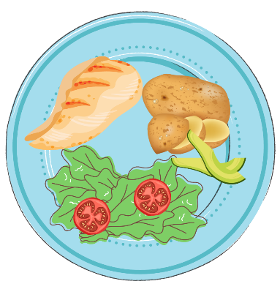
Carbs and grains
Healthy fats
Veggies
Fruits
Meal building foundations
Protein
100g cooked chicken breast  What would an example day look like?  What would an example lunch / dinner meal look like? | One heaped handful of spinach and a mixed handful of slice peppers | n/a | A 40g serving of nuts | 150g of boiled / microwaved baby potatoes
30 – 40g whey protein | n/a | A handful of blueberries and a kiwi | 20g of chia seeds | 60g of oats cooked by microwaving with almond milk
Here’s what an example plate would look like. Roughly speaking a portion of;
- Protein is around the size of your palm
- Veggies or fruit is around the size of your palm
- Your grains are roughly ½ to ¾ the size of your palm
- Your fats are roughly a thumb sized portion

Added notes;
- Rice, grains, pasta and potatoes to go by cooked weight and aiming for 150g cooked weight portions.
- Spices, salt and pepper are allowed as is garlic and added onion.
- Aim to oven roast / fry your proteins with 1kcal spray
- Sauces are allowed but try to use sparingly.
- Minimize liquid calories by including zero kcal swaps (e.g., diet coke for coke)
What would an example Breakfast meal look like?

Use the table below to slot in the foods above to give you an idea of what a typical day could look like
Here’s what an example plate would look like. Roughly speaking a portion of;
- Protein is around the size of your palm
- Veggies or fruit is around the size of your palm
- Your grains are roughly ½ to ¾ the size of your palm
- Your fats are roughly a thumb sized portion

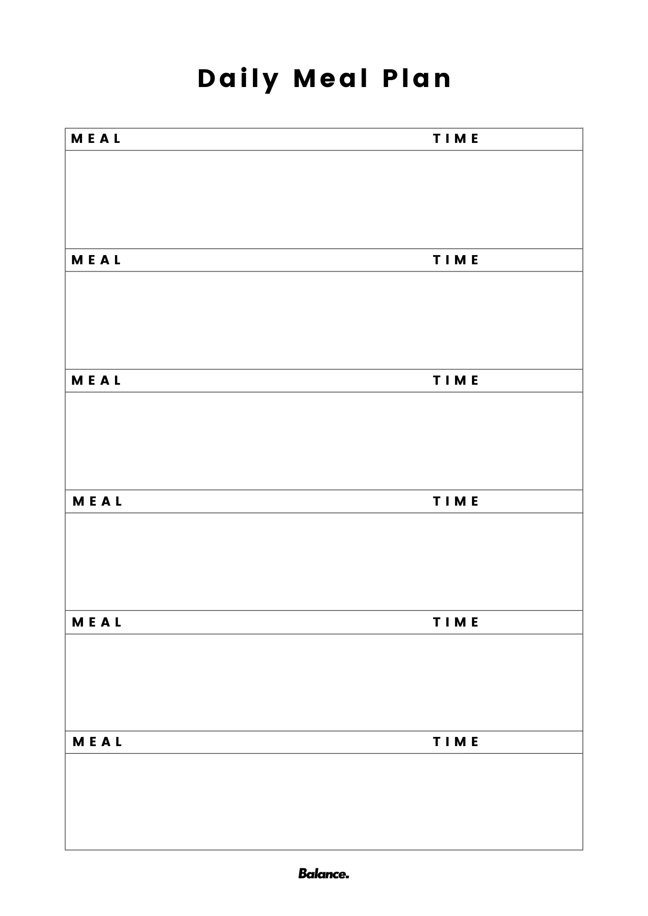
Whilst the meal builder is helpful and factors in energy intake, it may not always be feasible to use it. Being aware of portions and how we can use portion management on the fly can be helpful to ensure we’re fuelling ourselves adequately. Whilst quality of food choice is important so is the quantity. Quantity will impact weight change (or lack thereof) whereas quality of food will impact our health. These aren’t mutually exclusive but makes it a bit easier to understand and appreciate their individual importance when you separate the two.
Portion Control
Portion control is arguably the easiest and most straightforward technique to employ when regulating the amount of energy we take in via food.
I’d like to use this technique as it’s very fluid Jamie, yet there is a degree of control and simplicity. It’s a useful alternative to the meal building / planning which may come in “handy” (yes, that’s a pun and you’ll see why shortly).
Managing portions can be done easily in one of two ways; The first would be simply dividing up your plate. There are numerous iterations of this strategy (from the MyPlate in the U.S. to the EatWell Plate in the U.K.), and a general rule of thumb would be to divide your plate up into; 30 - 50% protein, 20 - 30% vegetables, 20 - 30% wholegrains and 5 - 10% fats.
The other simplistic method of portion management is to use your hands as a reference for portion size. This is what I’d like you to do moving forward Jamie if you’re not using recipes from our recipe books. I recommend using the following rules (as best you can) to determine portion sizes.
- Your palm determines your protein portions.
- Your palm determines your veggie portions.
- One cupped hand determines your carb portions (for women under 80kg)
- Two cupped hands determine your carb portions (for men under 90kg or women over 80kg)
- Three cupped hands determine your carb portions (for men over 90kg)
- Your thumb determines your legumes portions
- Your thumb determines your fat portions (unless referring to oils in which case it would be a tablespoon)
I’d advise using the above guidelines whilst also incorporating foods you’re comfortable with and recipes from the recipe books in our member’s area in the more immediate future (which are very much in line with these listed guidelines).

Now, what do you if you want to simplify this a step further?...

A greater focus on practicality

If practicality is the game, then ease of access is the aim!

And, what’s the most simplistic thing we can do that virtually everyone has access to use as a tool? Continue to use our hands as a portion management guide. We can even break it down to make it more straightforward if the situation is challenging.

Instead of getting hung up on achieving all of the previous guidelines whilst on the fly instead break it down and make it even more straightforward.

- Your palm determines your protein portions.
- Your palm determines your veggie portions.
- One to two cupped hand determines your carb portions
- Your thumb determines your fat portions (unless referring to oils in which case it would be a tablespoon)

With this you could even go a step further and simply aim to just minimize fat intake as best you can whilst focusing predominantly on protein and veggies / fruit.

One other simple way to eat on the fly (and if it’s more viable) is to give yourself an energy allotment and baseline targets for main meals / snacks.

For most people, the following guidelines will lead to an overall healthier dietary approach (in relation to the management of quality and quantity of food consumed).

- Aiming for between 400 – 600kcals per meal (with larger bodies / more active individuals requiring more calories per meal)
- Aiming for between 20 – 40g of protein per meal
- Aiming for at least 1 portion of fruit and or veg per meal

This may be particularly useful for those who are, for example, going for a meal deal option. If you have a rough estimate of energy intake for the total meal then you can find things which fit within it;
- A chicken wrap (350 kcals / 22g of protein)
- An apple or cereal bar (60 – 200kcals / 1 – 5/6g of protein)
- A bottle of water or zero kcal drink (diet Pepsi, coke, monster zero, black coffee etc.)

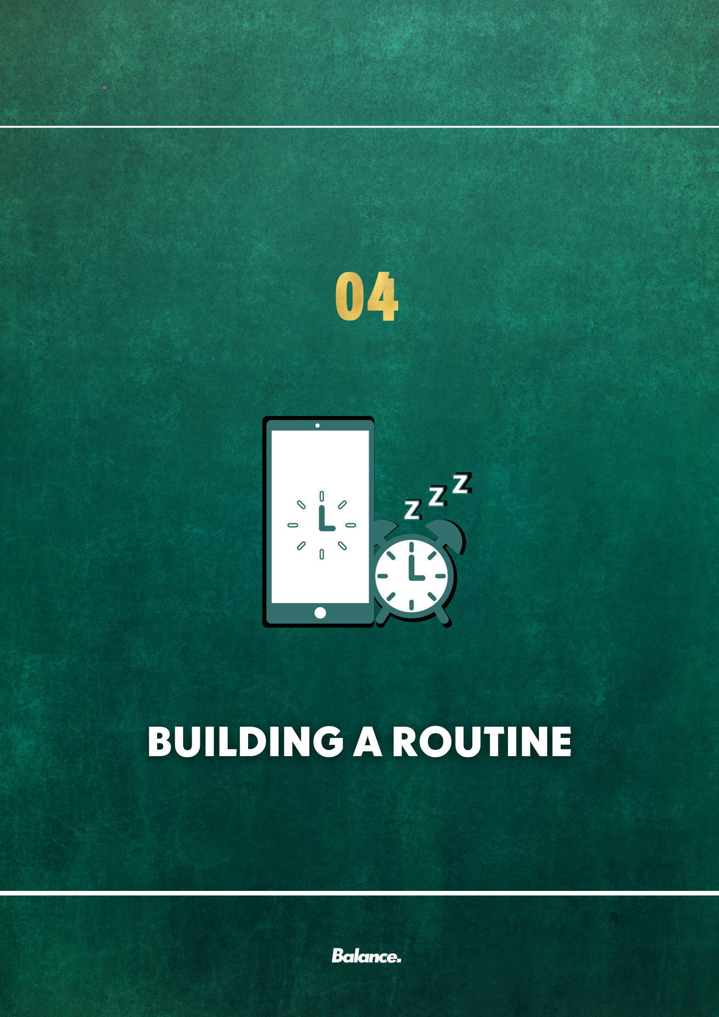

BUILDING A HEALTHY ROUTINE

Having a routine can be helpful at any time, particularly if you are trying to establish healthy habits. These routines can be particularly important when aspects of your life feel uncertain.
Some people love to have a solid daily routine, while others disgust at the thought of having a predictable schedule. During times of great stress and or change however, maintaining structure and routine can help you feel more organized and in control.
A lack of structure and routine can actually exacerbate feelings of distress and make you pay more attention to the source of your problems.
If people don't have structure and are sitting around with less to focus on, then they are also more likely to find themselves thinking about the stressful situation(s) more which can compact on, and add to, existing stress and anxiety.
The Benefits of Having a Routine
Research has consistently shown that routines can play an important role in mental health. Studies have found that routines could help people better manage stress and anxiety.
Having a regular routine can help you:
- Lower stress levels
- Form your desired (healthier) daily habits
- Take better care of your health
- Feel more productive
- Feel more focused

Getting necessary tasks out of the way can also help you find more time for healthy behaviours like exercise and leave you more time to enjoy fun activities and hobbies.
Building a routine
The key to building a routine that works for you is to create one which adds structure and a sense of predictability to your day. Of course, your schedule may change somewhat depending on the day of the week, but sticking to a basic structure for when you will wake, eat, work, do activities, and sleep can help you feel less stressed out and more organized.
Structuring your day also ensures that you accomplish those basic tasks that must be done; this will leave you with the time to schedule in other things that you want or need to accomplish.
Use our routine planner on the next page (which you can print or edit with the text boxes provided) to establish your wake and sleep times, meal and snack times, when you plan to exercise and, also, when you’re working and when you’re focusing on relaxation and “downtime”. You can also download it here.
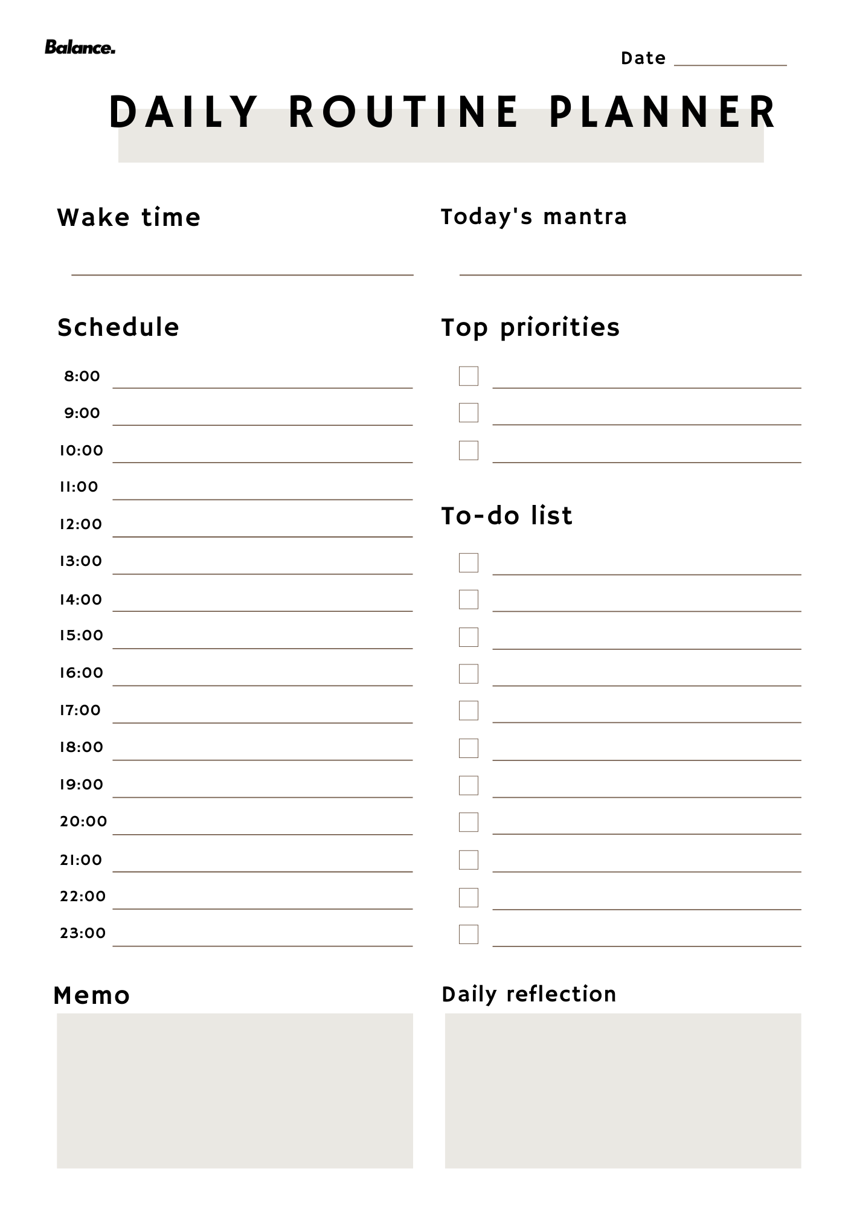

Whilst having a routine is important, give yourself some flexibility and don’t beat yourself up if you have trouble sticking to your own schedule. Everyone copes with stress differently. Having a routine can help you maintain a sense of normalcy and focus through tough times, but don’t stress yourself out more if you sometimes deviate from your plans.

How to develop a routine when you don’t have a set schedule
Developing a healthy routine is challenging in the best of times but it can feel damn-near impossible when you don’t have a set schedule.
If you work varying shift patterns, have education related scheduling demands, have kids or animals to manage with challenging schedules of their own or whatever else it could be, you know that your routine (or lack thereof) differs day on day.
If you want to create a morning routine, night routine – really ANY kind of routine – these tips will help you do that, regardless of your schedule.
Build on your “constants”
Even if you work varying shifts or your schedule changes from week to week, there are some constants in your day-to-day life.
For most of us, those constants are:
- Waking up and going to bed
- Eating
- Brushing our teeth, showering, etc.
- Exercise
- Getting to and from work
- Work itself

Once you identify these daily constants, you can begin to build your routine around them.
You can get up and go for a walk at 6am before breakfast if that’s what you want to do and, on the days, you’re working nightshift (just an example) you can get up a few hours before your shift starts to go on that same walk before having your first meal (equivalent to breakfast) that day.
Build a routine one piece at a time
One of the major problems we see for people trying to establish a routine is that they try to do introduce a brand-new routine all at one time. If you’ve ever tried to change everything in your life, all at once – regular meal times, a fixed bed time, no screens after 7 pm, journaling every night etc. – you know that it simply doesn’t work (or, at least, doesn’t last!).
Humans have a limited amount of self-control and decision-making that we can exert in a given day and trying to build a 100-part routine from nothing is a recipe for disaster and setting you up for failure.

Instead, choose ONE thing you’d like to anchor to a daily constant and start there. After a fortnight or so of doing that consistently, add one more thing.
Examples:
- Regular meal times
- Establishing a sleep routine
- Think about 5 things you’re grateful for while you brush your teeth
- Having a defined cut off point for work

This isn’t to say that you can’t try to incorporate several at these at one time which complement each other and are fairly simplistic to implement (if you have to honestly rate them out of difficulty of consistent application one a scale of 1 to 10, then having a number of 4 or 5 out of 10 rated habits would be more feasible to implement than several 7, 8 or 9 out of 10 habit changes).
The importance of accountability and support
Did you know…
We’re 65% more likely to achieve a goal – like creating a routine – when we have accountability.
Accountability and support look different for everyone. What works for you depends on your personality, your learning style and the demands on your time.
A few ideas for creating accountability and getting support:
- Communicate, communicate, communicate – support won’t work unless you actively interact with your support network
- Set alarms on your phone to check in with yourself. Every day at noon, or your approximate lunch time, check your phone and check “Did you journal today?”
- If you share a living space with someone, ask them to help to hold you accountable

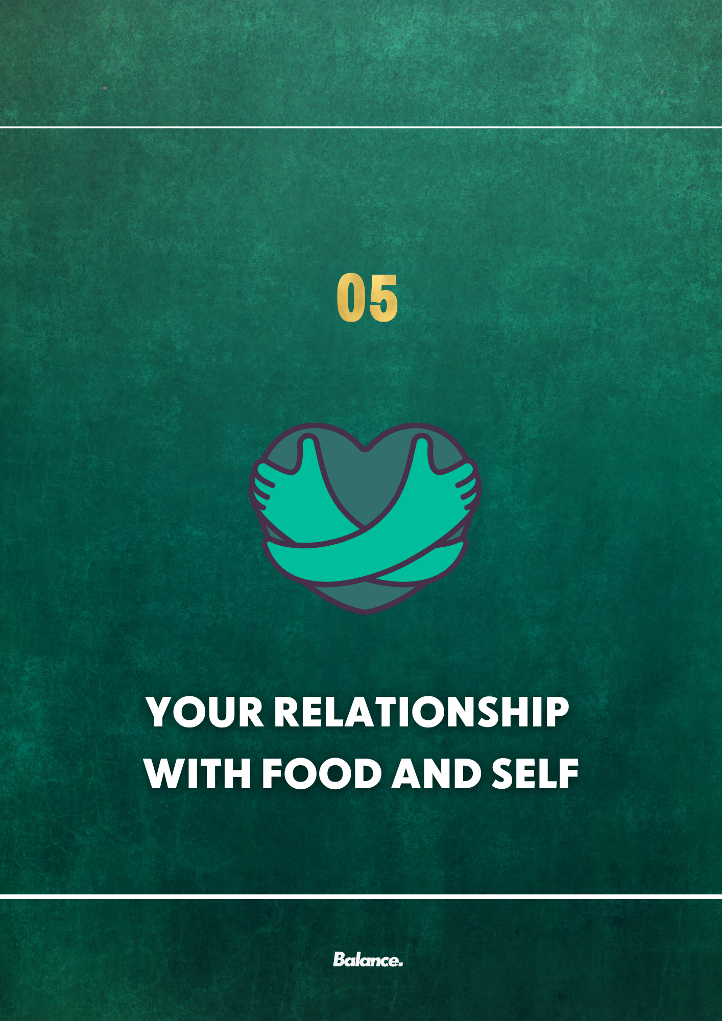

YOUR RELATIONSHIP WITH FOOD

Exploring that relationship with food and cultivating a healthier one
In this section we’re going to discuss how we can improve your relationship with food and self. Over the next 12 weeks we plan to implement a range of practices and strategies to overhaul these relationships and make significant steps towards freedom and happiness around food and self.

These practices will require continuous effort on your part; make no mistake, this process is challenging but this challenge will not only get you started on your individual journey of a peaceful and uplifting relationship with food and self, but also ensure you’ve made a great deal of progress along this journey.

The one thing we want to reiterate from day one is;

This is a process and, with any process, things will not always go our way.

These however are not failures.

These are “learning moments”; when we view any setback or undesired outcome through the lens of learning then, one day, we’ll find ourselves in a position of “success” or, if you prefer, much closer to the person you’ve hoped to be and the best version of yourself you’ll be continually working towards.

We’d encourage you to communicate with us, particularly early on, when it comes to these moments. It would be naïve of us to expect you to be able to shape all of these experiences positively from day one; that’s why we’re here. As a support network and objective challenger to the critical narratives which may be within your mind before, during and after those moments.

Now, here is the format for the next 12 weeks (which may vary dependent on your progression but this is at least a rough outline for the implementation of our strategies for the next few months).

Each new strategy / practice we introduce is designed to build upon those that have come before it. This stage-by-stage implementation should be a useful means of you constructing your own “toolbox” of techniques which you can use throughout this process (and beyond) to improve, and continue to improve, your relationship with food and self.

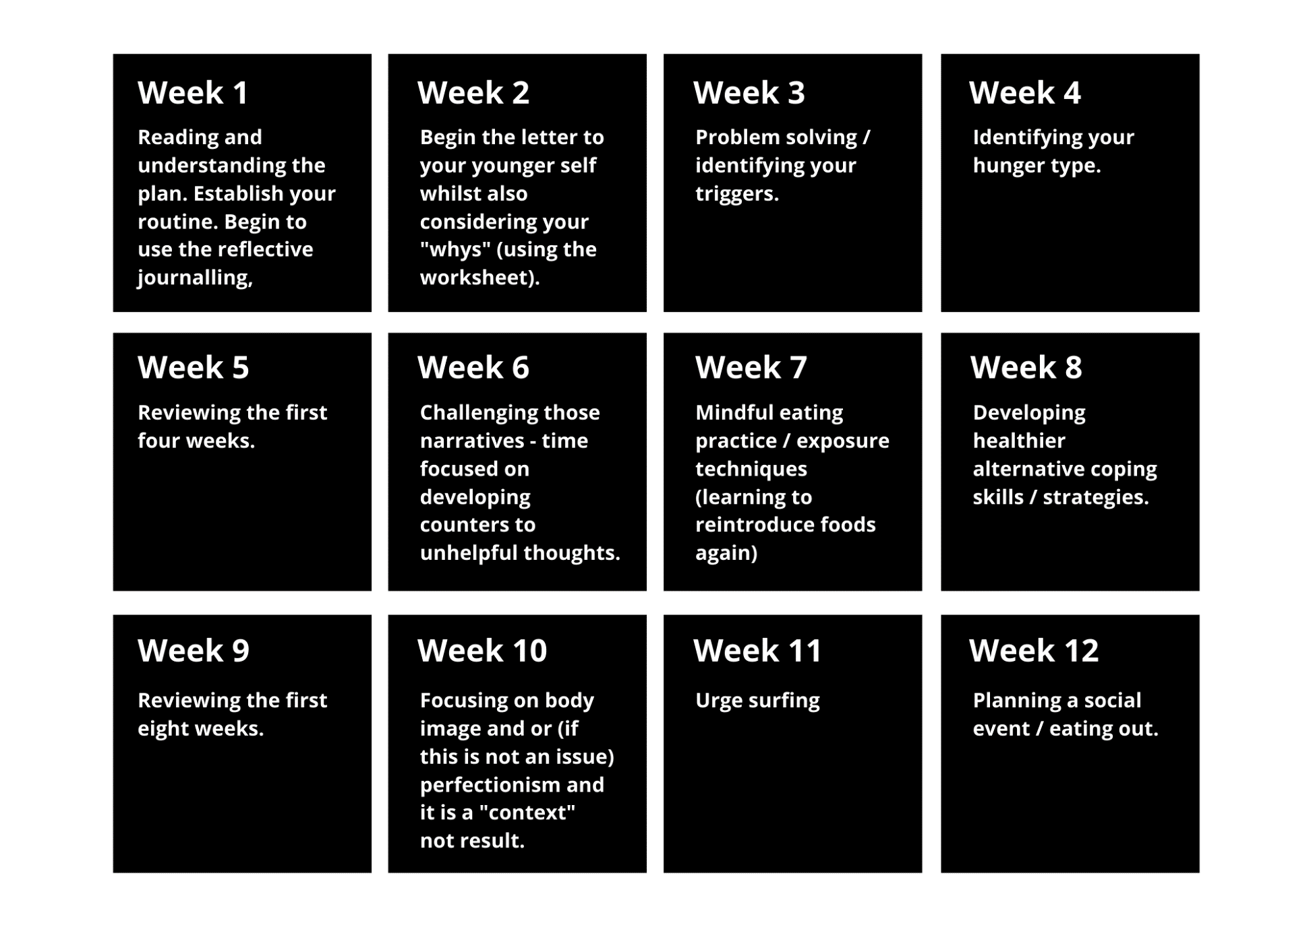
Outlining our process for the foreseeable future
Over the next 12 weeks we’ll be following this rough outline as we progress towards improving your relationship with food and self.

Along the way we will be linking you to exercises to use in conjunction with our focus for that week.

This may not always be linear so if you feel that we are moving too fast or you’re not ready to trial the given focus for that week please just say.

Over the next few pages of your plan, you will find the strategies and practices for weeks 1 and 2; this is because we’d ideally like you to use the reflective journalling as soon as you’ve understood the plan and then get started on the letter, as well as the “whys”, towards the end of week 1 start of week 2.

It’s important to reiterate however that you do not rush.

This whole process is going to go at your pace, not ours. It can however be helpful to know that there is a format in place for how we work as that can make you feel more secure in knowing the plan and what it will look like.
Understanding our past

Step 1: Understanding yourself
The first step to understanding your food choices Jamie is to understand yourself, your values and your beliefs. Belief drives behaviour, so my intention here is to help you map out and understand the roadmap of your journey with yourself and food; where certain behaviours come from and why they've manifested, then we can begin to forgive ourselves, shed that feeling of guilt and move on to the next chapter in our lives.

Write a letter to your younger self – may want to include or exclude this based on individual
I’d like you to write a letter to your younger self, as your present self, from when you can remember your first time you recall using food in an emotional way and it wasn't in your control. I want you to explain to them why you think it happened; talk about that time, what you felt, how people made you feel (family, friends, talk about control, talk about how you feel about yourself, talk about where you’re at now and where you’re going to be; who you’re going to be and why it’s ok to forgive yourself. Why it’s ok to love yourself because of who you are.

This can be a really helpful exercise for putting together the pieces of your “puzzle” i.e., road mapping out how you got your present point.

If you struggle with starting the letter our advice would be to simply see it as a fluid conversation. Imagine you were discussing a subject with your best friend and or partner and write in that way. It doesn’t have to be grammatically correct or even presented to me; it’s simply meant to get your brain thinking about this process in a different manner.

To step away from the constant cycle of critical self-talk by actually identifying where this started and then beginning to figure out “why” we do what we do.

You don’t get mad at the water filling up the boat if it’s sinking do you? No, you look for the hole in which it’s coming in; focus on the source (the “why”) and not the outcome (the “what” – as in “what we do”).

The 5 Whys
The “5 Whys” is a very simple system which helps reveal our deep motivations of why we want something.

When you want to accomplish something, you ask one “why.”
“Why do I want to accomplish this?”
Then, whatever answer you come up with, ask why again. And so on, five times. As you answer these questions:

• Be honest about your intentions.
• Be curious about what’s beneath the surface.
• Be compassionate with yourself.

I want you to complete the ‘5 whys’ exercise in this worksheet (download here) indicating your overall goal.

Manging our present whilst we work through our past

Self-Monitoring
The first thing I would like you to do is to take a step back and observe, identify, and understand your eating behaviour. And the best way to achieve this is via self-monitoring. Self-monitoring simply means recording your thoughts, feelings, and behaviours towards food and eating in real-time or as they occur.
Completing daily records of your eating patterns may provide you with important information about your disordered eating / critical self-talk Jamie. In essence, it allows you to become a detective, searching for clues about any problem eating behaviour you might regularly encounter. This helps address our present behaviours.
With monitoring, you might eventually find out that, for example, you only emotionally eat when you’ve skipped lunch, or when you’ve had an argument with your spouse, or maybe when you’ve broken one of your strict food rules, or maybe when you’re feeling bored.
So, by recording your thoughts, feelings, and behaviours, it becomes easier to be aware of
the specific and harmful patterns that maintain your emotional eating. And once you become aware of what is going on, you will find it much easier to change, because you will know what needs changing.
You can do this in any format you wish, even just blank page journaling is super helpful however if you need a little bit more guidance and structure, I have found the below extremely useful with my previous clients. In the past clients have also used voice recordings and even video diaries too! It is a good idea to have one form per day so that you can record your relevant behaviours, thoughts, and emotions. This is what you should be recording:
- Time: the exact time you ate or drank anything.
- Food & drink consumed: what it was that you ate or drank during that period of time. Be descriptive and don’t leave anything out.
- Place: where you were when you consumed this. Was it your bedroom? Kitchen? Friends place?
- Excessive: did you perceive this episode of eating to be excessive or too much?
- Hunger level: on a scale of 0 (starving) to 10 (stuffed), rate how hungry you were before you started eating.
- My reflection: anything relevant to note before, during, or after this episode of eating. This may include your emotions or thoughts related to eating or anything that may have contributed to your eating.
You will find a sample template here which you can use and if you wish, you can email me across your completed templates (daily/weekly) so we can begin to note and record any trends or behaviours that may trigger emotional eating.

Developing compassionate and empathetic self-talk
Self-compassion and empathy will go a long way in this process. Alongside our support network we must also develop the ability to become our own ally.

This can be extremely difficult if we’ve lived with abusive self-talk for many years. One thing that I’d like for you to understand is that the abusive, irrational voice is one that is also trying to protect you, it’s just severely misled. Through experiences and the compacting impact of repetitive practice over time, it has become the dominant voice in your head.

There is still a rational, compassionate voice in there, they’re just much quieter. As difficult as it can seem though we can give this voice life and raise its volume over time by challenging the abusive voice.

Through understanding of “why” we do what we do as well as how we think and where our beliefs stem from, we can then begin to challenge this voice. It takes consistent effort but the rewards for doing so are immeasurable. The day that you realize that you haven’t been highly critical or nasty to yourself in days, weeks, months or even years is one of the best days you’ll ever have.

If you do find though that there are moments where the critical voice becomes very loud, I find a very simple process to “escape” the emotion of a moment it is to use a laddering system of objective, immediate reflection.

When you feel like you may be considering or in the midst of a downward spiral or unhelpful self-talk consider this;

- This is a moment of pain, suffering, guilt, shame (or whatever else you’d like to describe it as)
- This is a normal emotion; we all experience “x”, I have experienced it before and I have survived it and I am in the process of overcoming this.
- This is a part of life; the emotion is not always in my control, but I have an opportunity to decide my action and my interpretation of this moment. Many people have felt this before, I am not alone in this moment. I can use it to build the story of a life I want to live
- “I am worthy of being kind to myself and I am an intrinsically good person who wishes good things for others” – your self-worth is an ongoing battle Jamie and each and every moment is a fight to improve it. Understand that you are all one in the same; there is no “good” or “bad” Jamie, it’s all Jamie and you are a good person, who is more than worthy of kindness, not just in this moment, but all moments to come. You are someone who is worthy of loving themselves because of who they are, not this action or thought that you’ve had or have had in the past.

The importance of valuing food and how it makes us feel
This is another useful and important component to add in shifting your current perspective on food and your attitudes towards it Jamie.

This is a super simple approach I use which is incredibly liberating for those I work with; to realize they can achieve progress without sacrificing the joy of food.

Most of the time we want to aim to include foods which are nutritionally dense, higher in protein, higher in fibre; your prototypical "healthy" foods. However, slowly incorporating a small number of foods that you're eating purely for the joy, flavour and experience of the food is important too; the chocolates, sweets, crisps or whatever else you’d throw into this bracket. Allowing ourselves these foods is important as it takes away that element of “guilt” associated with them whilst ultimately reducing our desire to overeat / crave them. You don’t crave what’s accessible after all.
Discretionary Calories is a term used to describe the difference between an individual’s calorie requirements and the calories consumed to meet necessary micronutrient (vitamins and minerals) intakes. To put this into context, once you have eaten enough vegetables, fruits and quality protein, you may find that you still have some wiggle room left over.
The thing is, you don’t get bonus points for eating more nutrients than you need! In fact, non-nutrient dense foods that are low in fibre and easy to consume may actually be necessary for active individuals such as yourself Jamie, who need to meet high energy demands.
I use this more flexible approach to help people find that balance between eating for health and eating for joy – both important (and strangely interrelated) and a great approach to adopt for having a healthy relationship with food. I feel like we’re too “black and white” in our focuses. We’re either all in or all out with food (much like other things in life) when, in reality, the healthiest, and most sustainable, approach is really allowing for these foods that we do love and we do have an emotional attachment to and then developing these same attachments with the more nutritionally dense foods over time (as we begin to experience their health benefits, our palettes begin to change, we experience changes in our body, mental state etc.).

We want to remove the grasp of morality around food (no more “bad” food talk; it’s just food!) and have almost a non-binary approach or one centred around “all food is good food; it just depends on the context of its use”. It’s an approach I use frequently with clients and I’ve found it to be hugely beneficial to those dealing with disordered eating like behaviours and poor relationships with food. It’s a way that we can still achieve our goals, satisfy our psychological needs but also co-exist with, instead of fighting against our, current food environment.

If you feel like you are struggling at all though Jamie, please, please, please message me. I’m always available (literally) for a chat! I encourage variety and choice with my clients.

Food is fuel, but food is also something to enjoy and look forward to. It’s also very important from a social perspective which is another important component of health. I’ve literally dealt with the whole spectrum of disordered eating myself, so I can empathize with you if you feel you are struggling. It should be comforting to know though, that it is possible to fix and it’s worth all the effort to fix it as it’s like “unlocking a prison cage” when you can finally be comfortable and trust yourself and food and be happy in doing so.
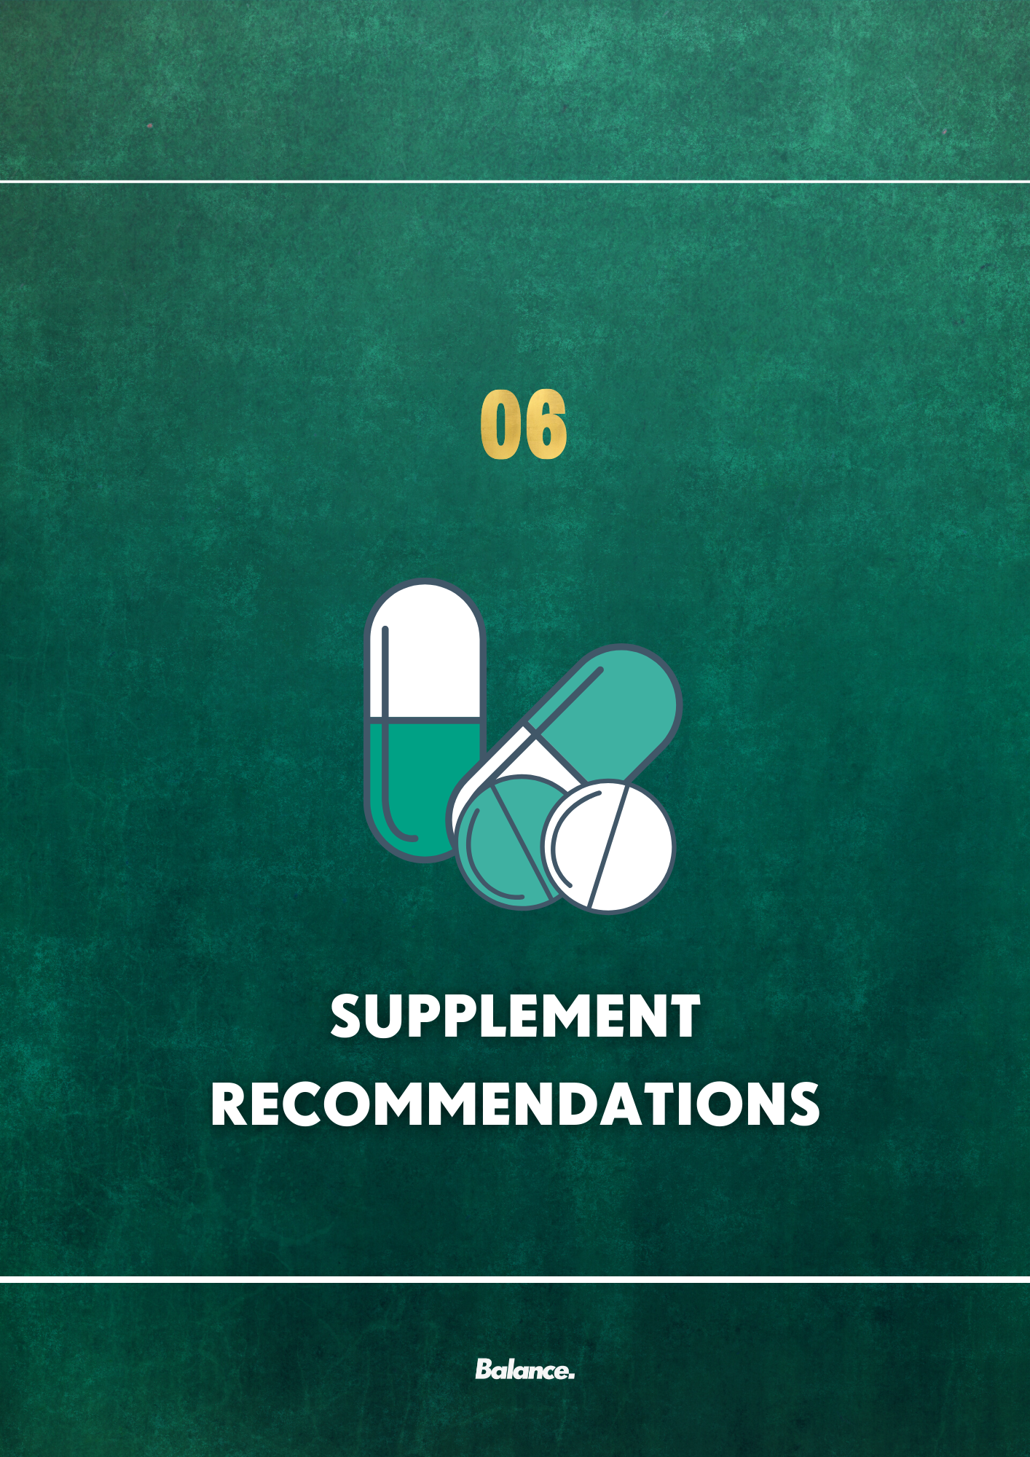
3

SUPPLEMENT RECOMMENDATIONS

Generally, I do believe in a ‘food first’ approach Jamie as it’s important to get the basics right first as they will have the greatest impact. However, the balance between what would be “ideal” and what is “practical” must be considered.
I want to keep it incredibly simple from the start Jamie. Can you give me a bit of a breakdown of the brands and dosages of supplements you’re taking at the moment / have taken in the past?

On to my recommendations (just one to begin with);
I’d highly recommend the following (if not already taking);
- Omega 3s
- Vitamin D
- A “PMS” Stack
The first supplement I’d like to recommend is an omega-3 polyunsaturated fatty acid supplement. Achieving consistent adequate intake of omega 3s can be hugely beneficial to maintaining/improving our health; benefiting everything from cognitive health to insulin resistance/sensitivity. It has also been shown to have a protective effect against certain cancers, cardiovascular disease and cognitive decline. It can also contribute to improved mental health Jamie! Fish is quite expensive (and fish rich is omega-3s may be kcal dense), so supplementing is a perfect, cost-effective option. Aim for 1 – 2g per day. Reflex do a great one here and if you use the code PTWRIGHT357 you’ll get 40% off
The second supplement I’d like to recommend is one you’re already taking and that’s vitamin D Jamie. I’m not sure of your present dosage but I’d like for you to be aiming for around 2000I.U a day. No one gets enough vitamin D and it can help with everything from your immune system to bone mass density and mental health! It has also been shown to have a protective effect, like omega 3, against the likes of certain cancers and cognitive decline. The only supplement people actually “need” (regardless if people call it a supplement or not) and if you’re already achieving this intake that’s great! Here’s a trusted brand to use Jamie If you use the code PTWRIGHT357 you’ll get 40% off If you can’t source these please let me know and we’ll find alternatives!
Thirdly, I’d also recommend picking up some supplements to take specifically in the week leading up to menstruation. Studies have shown women who suffer with PMS symptoms to be deficient in magnesium and zinc. The greater the deficiency the more severe the symptoms in many cases.

Magnesium is essential for the brain’s synthesis of dopamine (the “pleasure” neurotransmitter). A deficiency of dopamine (an imbalance) can lead to overwhelming anxiety. Studies have found that women who suffer with PMS have lower concentrations of magnesium possibly suggesting that it may play a key role in the presentation of PMS symptoms.

Supplementation of magnesium has been shown to significantly improve PMS symptoms. You’d be aiming to supplement 250mg of magnesium (threonate, bigylcinate or citrate) daily in the week leading up to menstruation and you can get it for relatively cheap from any large supermarket or a Boots / Superdrug.

Zinc levels have also been found to be significantly lower in women with PMS. Whilst the mechanisms surrounding how zinc may be of benefit are not fully understood, fixing the deficiency does have a beneficial impact on PMS symptoms. You’d be aiming to supplement 45mg of zinc (citrate if possible) daily in the week leading up to menstruation and, just like magnesium, you can get it for relatively cheap from any large supermarket or a Boots / Superdrug.

On to my final recommendation, whey protein. I actually consider it more of a food than a supplement which is why I didn’t list it! Whey is probably the most researched of all the protein supplements and is generally considered superior in terms of muscle protein synthesis (muscle building) and for sports performance. The International Society of Sports Nutrition recommends that those who exercise should try to reach their protein requirements via whole foods, but protein supplements can be a practical and easy way for athletes to meet their increased protein requirements quickly after a workout or on the go. It’s also an incredibly useful tool for weight management too!

I love whey and I think it’d make a great addition to anyone’s pantry, making it more easy, efficient and affordable to hit their protein targets. Doesn’t always have to be in a shake either. Make a shake and pour over cereal. Mix a scoop in with oats. Add it to baking recipes etc. it’s incredibly versatile and overall, a great, great source of nutrients. It can also be helpful for people who experience exercise-induced poor appetite after high intensity exercise or digestive issues after exercise.

There are also options for those who are lactose intolerant/ dealing with IBS like symptoms. The isolate version of whey protein involves a further manufacturing step in which all lactose has been removed from the product and they add in extra lactase enzymes (which help breakdown lactose) to further negate any digestive issues associated with ingestion. If you’d like me to link you to these specifically Jamie if they’d be more ideal for you let me know!

Do your homework, find the supplement/brand that suits you (ask for a sample first!),
Personally, I’d recommend Reflex, Bulk or Myprotein; cost effective and great quality!
Have you used it in the past? If so, which brands have you used?

Performance related supplements/ Other considerations
Caffeine
I know a lot of people are against it but I’m the kind of coach who emphasises restriction on restricting foods and or dietary components. Caffeine is one of my favourite tools for improving performance. Caffeine is personal preference but anywhere between 100 - 200 mg prior to performance (an americano or sugar free energy drink) will elicit a range of benefits related to both improving performance as well as body composition.

I wouldn’t recommend having any more than 300mg a day and not taking it after 4pm in the afternoon (unless you’re experienced with it and it doesn’t impact on your sleep).
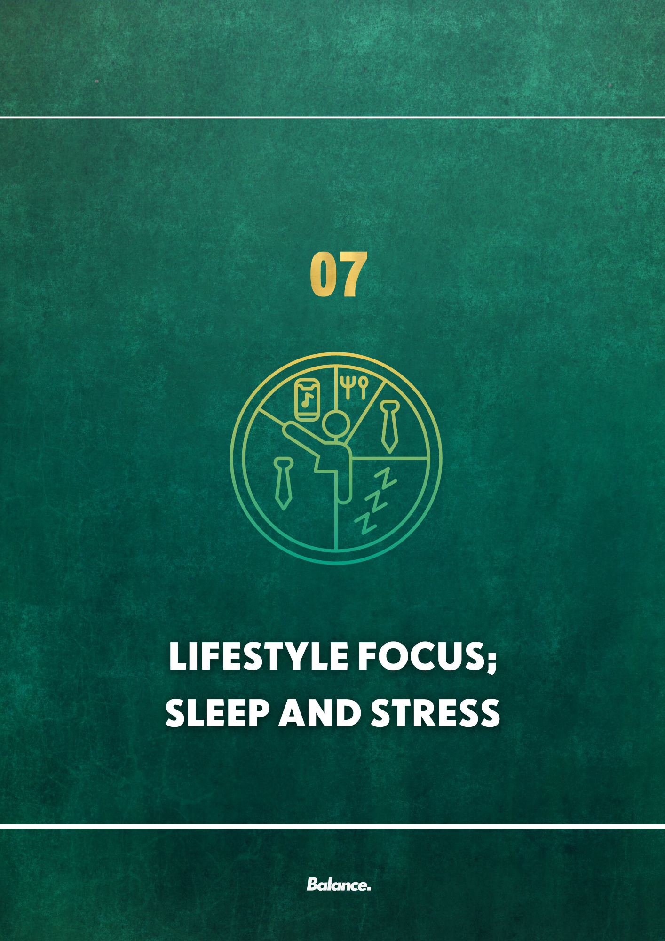

LIFESTYLE

There are two main lifestyle aspects we like to cover; sleep and stress.

Sleep is incredibly important for yourself Jamie, considering your high activity output and just in general to improve all aspects of their health and I’m glad to hear you prioritise and love sleep too!
Sleep must be the number one priority for anyone looking to improve their health, improve their performance or generally feel amazing!
Let’s start with what’s optimal,
- A Perfect night.
-7-9.5 hours a night, deep restful sleep.
- The Perfect setting.
-Relatively cold room
-PITCH black, zero light, even the little LED on the TV can affect deep sleep.
- The last 60-90 minutes pre bed,
-no electricity plugged in around the bed
-the means your phone,
-yes, no phone,
- …. But if you’re going to use it, download a blue light filter as blue light can mimic natural light which our brain interprets as waking hours and delays our sleep onset.

Reduced sleep quality and quantity has been directly associated with significant increases in stress and reduced blood sugar control (leading to unwanted cravings and a propensity towards uncontrolled snacking). It can also lead to more fat deposition around the midline and increases in central adiposity. It can also have a significant detriment to performance and exercise recovery and adaptation; basically, it’s super important!

Your sleeping pattern is generally ok Jamie but something I’d like us to improve on to push up to that 7 – 9 hours a night consistently Have you a pre-bed routine? Are there any hurdles to achieving 7 – 9 hours a night? I also recommend that you choose a 60-minute pre-bed activity which allows them to chill out. I call this activity a ‘Least Mode’ activity and this can include reading, journaling, meditating etc.

Stress is the other big one for us to tackle Jamie. I believe it’s contributing to some of the current issues you’re dealing with. I’d really like to better understand your current stress situation and help to manage it if I can. Does it vary extremely? Would it come on quite suddenly or more gradual?

Can I ask; Is there anything in particular that causes this stress? Outside of the difficulties you If there are additional stressors, would you say they’re more work related or health related?
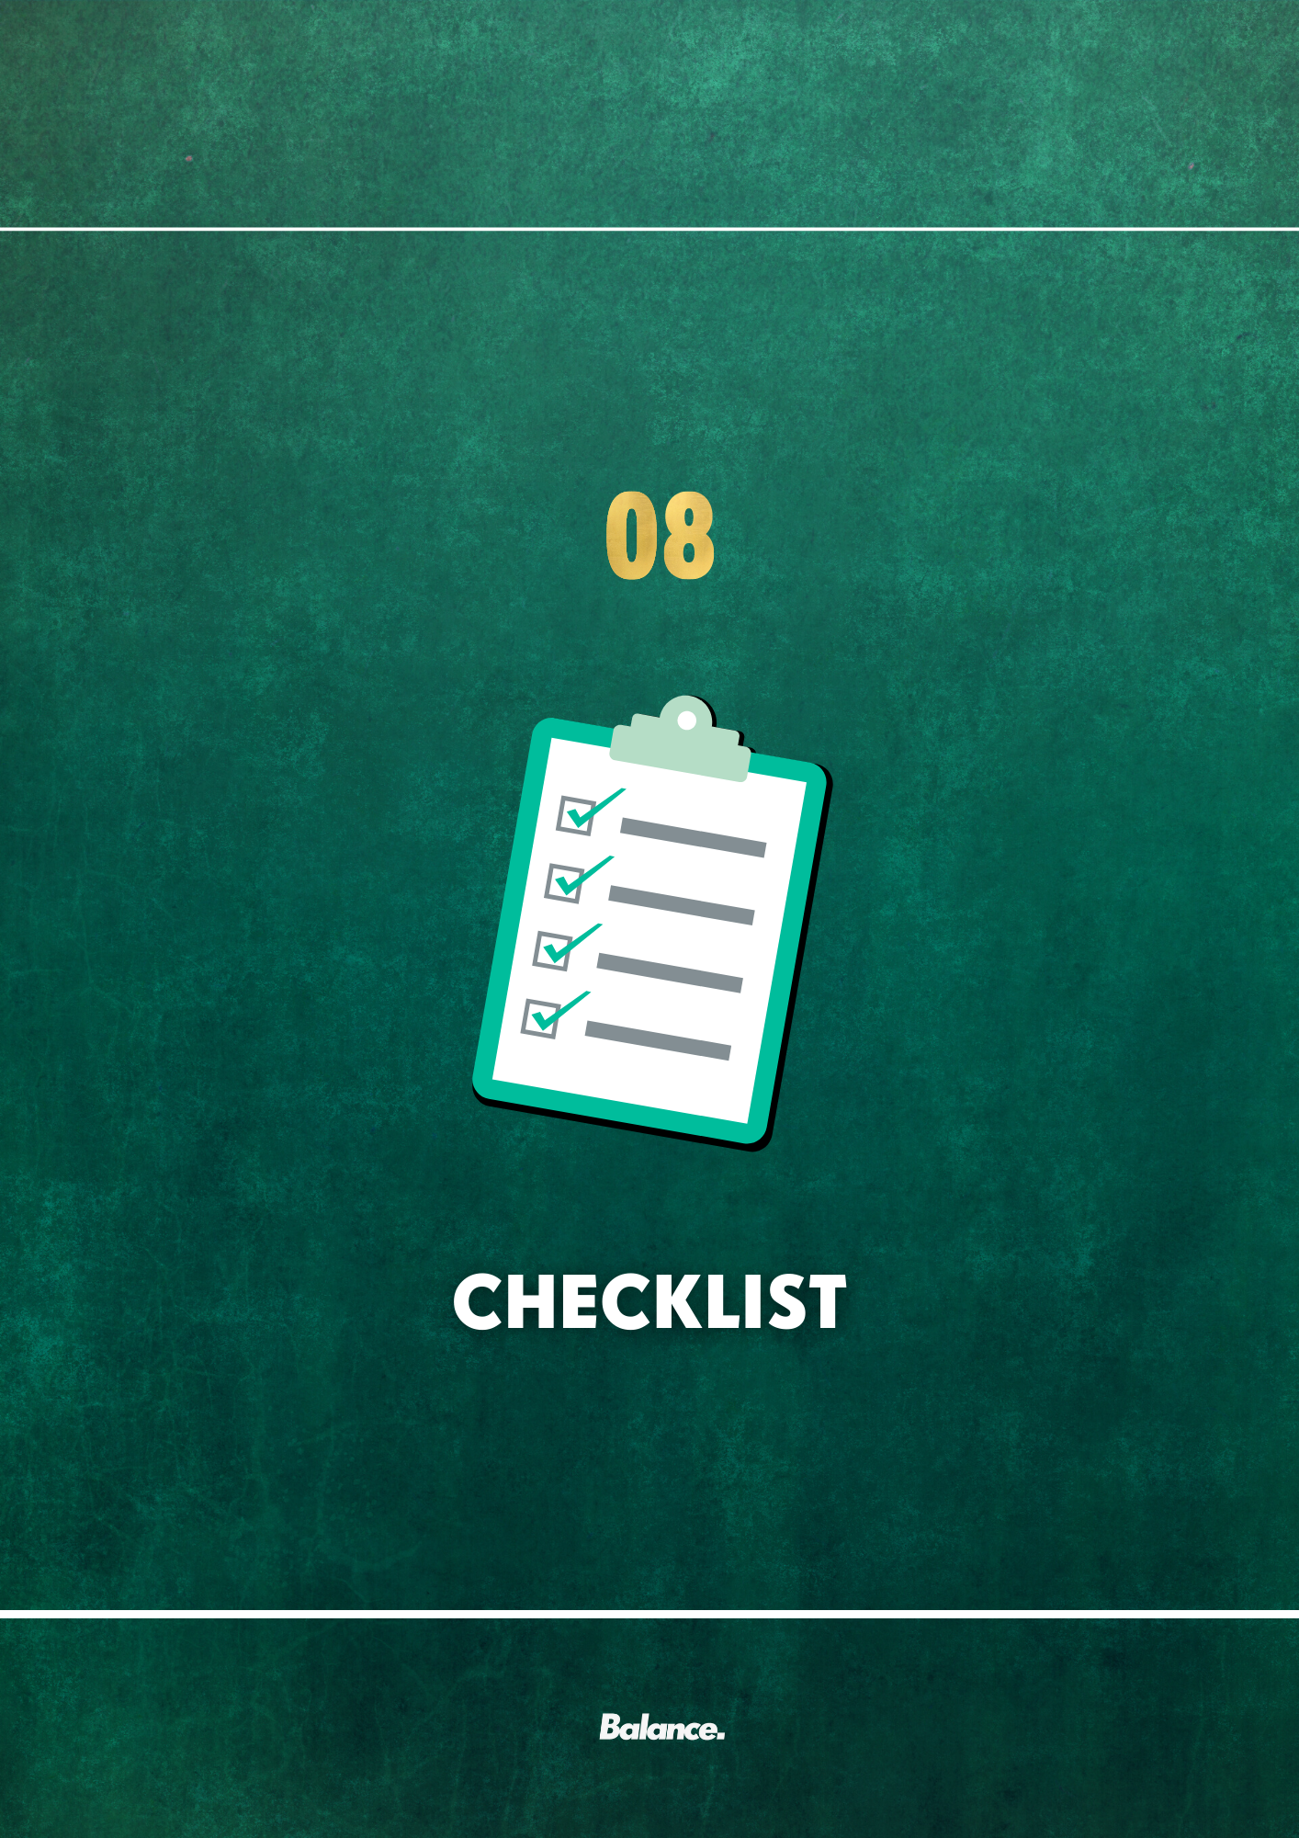

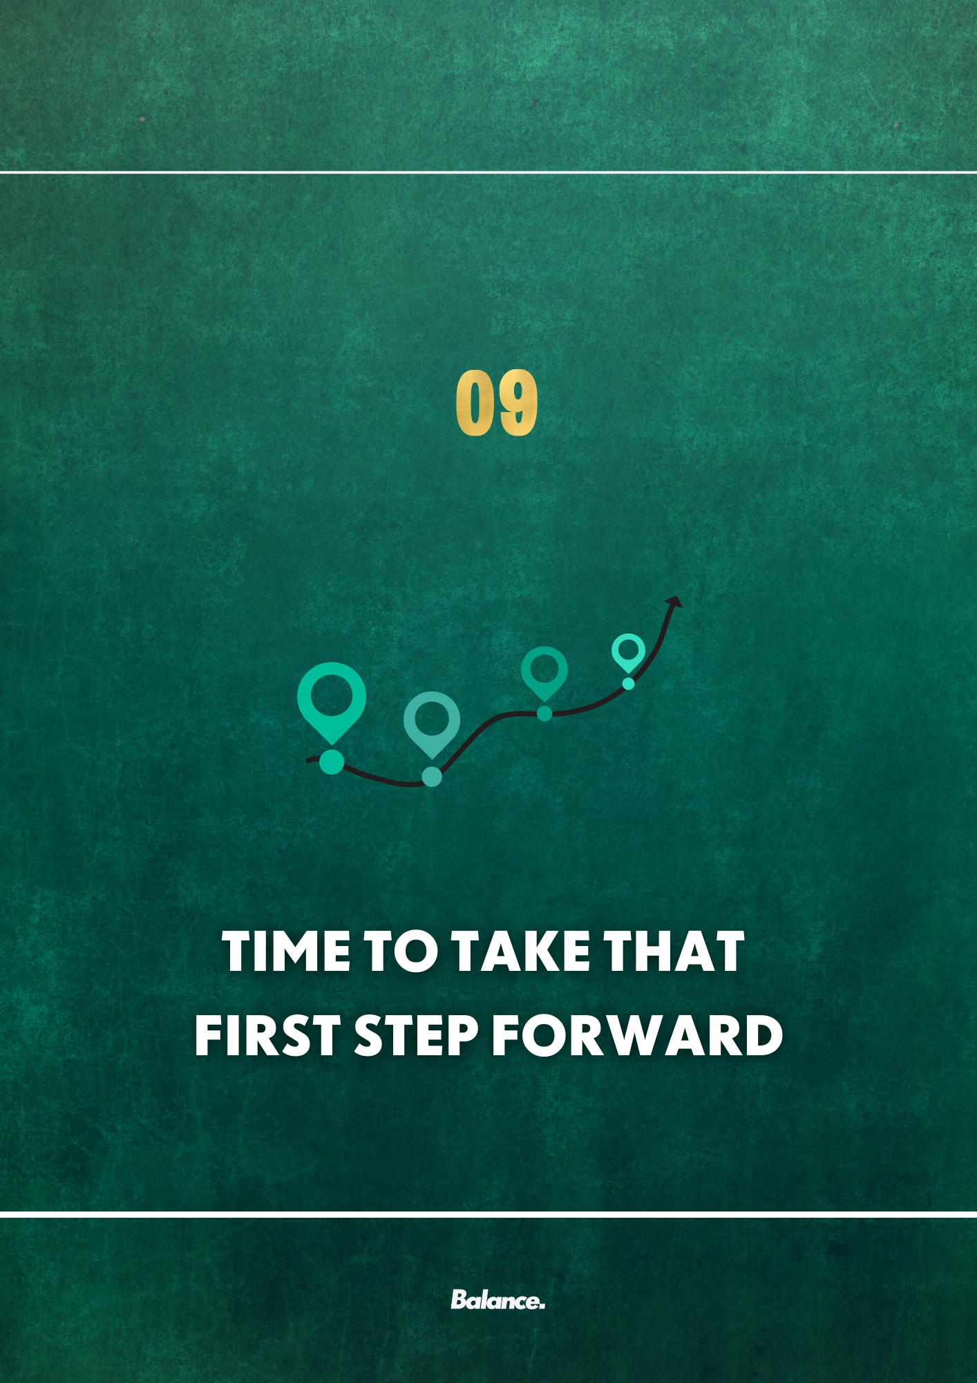

CHECKLIST

We put a lot of detail into our plans so we want to make it as straightforward for you as possible Jamie to know what you should be doing from day one.
For that reason, we’ve constructed a check list of what we’d like you to be doing from this point onward (and this will of course gradually change over time as we introduce new strategies etc.).
We’ve broken it down into;
- Constant focuses (those which will remain an ongoing focus of ours)
- Constants that will change over time (strategies that may change as improvements are made)
- Focuses for the first two weeks

Type of focus | Task | Completed
Constant focus | Establishing and maintaining a routine | ☐
Constant focus | Building a meal schedule and rough plan using the routine planner and meal builder / plan resources | ☐
Constant focus | Communicating with us throughout the process | ☐
Constants that will change over time | Self-monitoring journal | ☐
Focuses for the first two weeks | The worksheets we’ve alluded to in your plan | ☐
Focuses for the first two weeks | Making sure everything makes sense and if you have any questions, you’ve asked them to your coach. | ☐

MOVING FORWARD

Take your time to read over these and let me know your thoughts. These are things we can and will work together on to achieve your goals and I'd prefer you to be totally transparent and honest.

In summary
- Use the SMART goal worksheet to establish your goals and send them to me
- Use the meal builder and planner to draw up what a typical day will look like; feel free to message me to collaborate with me
- Use the routine building worksheet to give yourself a rough outline for your day
- Don’t be afraid to have something you enjoy in your diet if you’ve met your other requirements and recommendations (80/20 rule!)
- Keep an open dialogue with me and use your journaling and objective narrative reframing to improve your relationship with yourself; hating our body offers no value. When we engage in these processes Jamie our narrative around the situation is critical. You aren’t punishing yourself. You’re making these changes because you love yourself, and you want to see how great you can be (and I’m going to help you get there!)
- Try to keep your food sources varied when practically feasible to do so.
- DON’T BE AFRAID TO QUESTION WHAT I’VE RECOMMENDED AND SPEAK TO ME. I don’t want you following it like a robot. Be inquisitive. That’s how you learn and become better with nutrition (and vice versa!), I’m your support and your person to vent to in this process. Use me as much as you can, when you can, when you need to! Use my experience to your advantage and we can overcome all the hurdles!

In Summary
- Our primary goal is to improve your relationship with self and food, as well as your body composition and overall health (both mental and physical).
- Our secondary goals are to; focus on self-talk, reduce / fully mitigate binging episodes by targeting the source, adapt an “80/20” approach to eating and increase our fruit and veg intake.
- Our tertiary goal will be to ensure that you’re learning a lot from this entire process; I don’t want you to need me after a while and I believe that’s your goal too

Have a good read and let me know if it makes sense,

Any questions just let me know!

Excited to get to work with you Jamie! Remember to check in with me here

“Compare yourself to who you were yesterday, not to who someone else is today”

Jamie

