Building a routine and why it matters
Having a routine can be helpful at any time, particularly if you are trying to establish healthy habits, but these routines can be particularly important when aspects of your life feel uncertain.
Some people love to have a solid daily routine, while others disgust at the thought of having a predictable schedule. During times of great stress and or change however, maintaining structure and routine can help you feel more organized and in control.
A lack of structure and routine can actually exacerbate feelings of distress and make you pay more attention to the source of your problems.
If people don't have structure and are sitting around with less to focus on, then they are also more likely to find themselves thinking about the stressful situation(s) more which can compact on, and add to, existing stress and anxiety.
The Benefits of Having a Routine
Research has consistently shown that routines can play an important role in mental health. Studies have found that routines could help people better manage stress and anxiety.
Having a regular routine can help you:
- Lower stress levels
- Form your desired (healthier) daily habits
- Take better care of your health
- Feel more productive
- Feel more focused
Getting necessary tasks out of the way can also help you find more time for healthy behaviours like exercise and leave you more time to enjoy fun activities and hobbies.
Building a routine
The key to building a routine that works for you is to create one which adds structure and a sense of predictability to your day. Of course, your schedule may change somewhat depending on the day of the week, but sticking to a basic structure for when you will wake, eat, work, do activities, and sleep can help you feel less stressed out and more organized.
Structuring your day also ensures that you accomplish those basic tasks that must be done; this will leave you with the time to schedule in other things that you want or need to accomplish.
Use our routine planner on the next page (which you can print or edit with the text boxes provided) to establish your wake and sleep times, meal and snack times, when you plan to exercise and, also, when you’re working and when you’re focusing on relaxation and “downtime”.
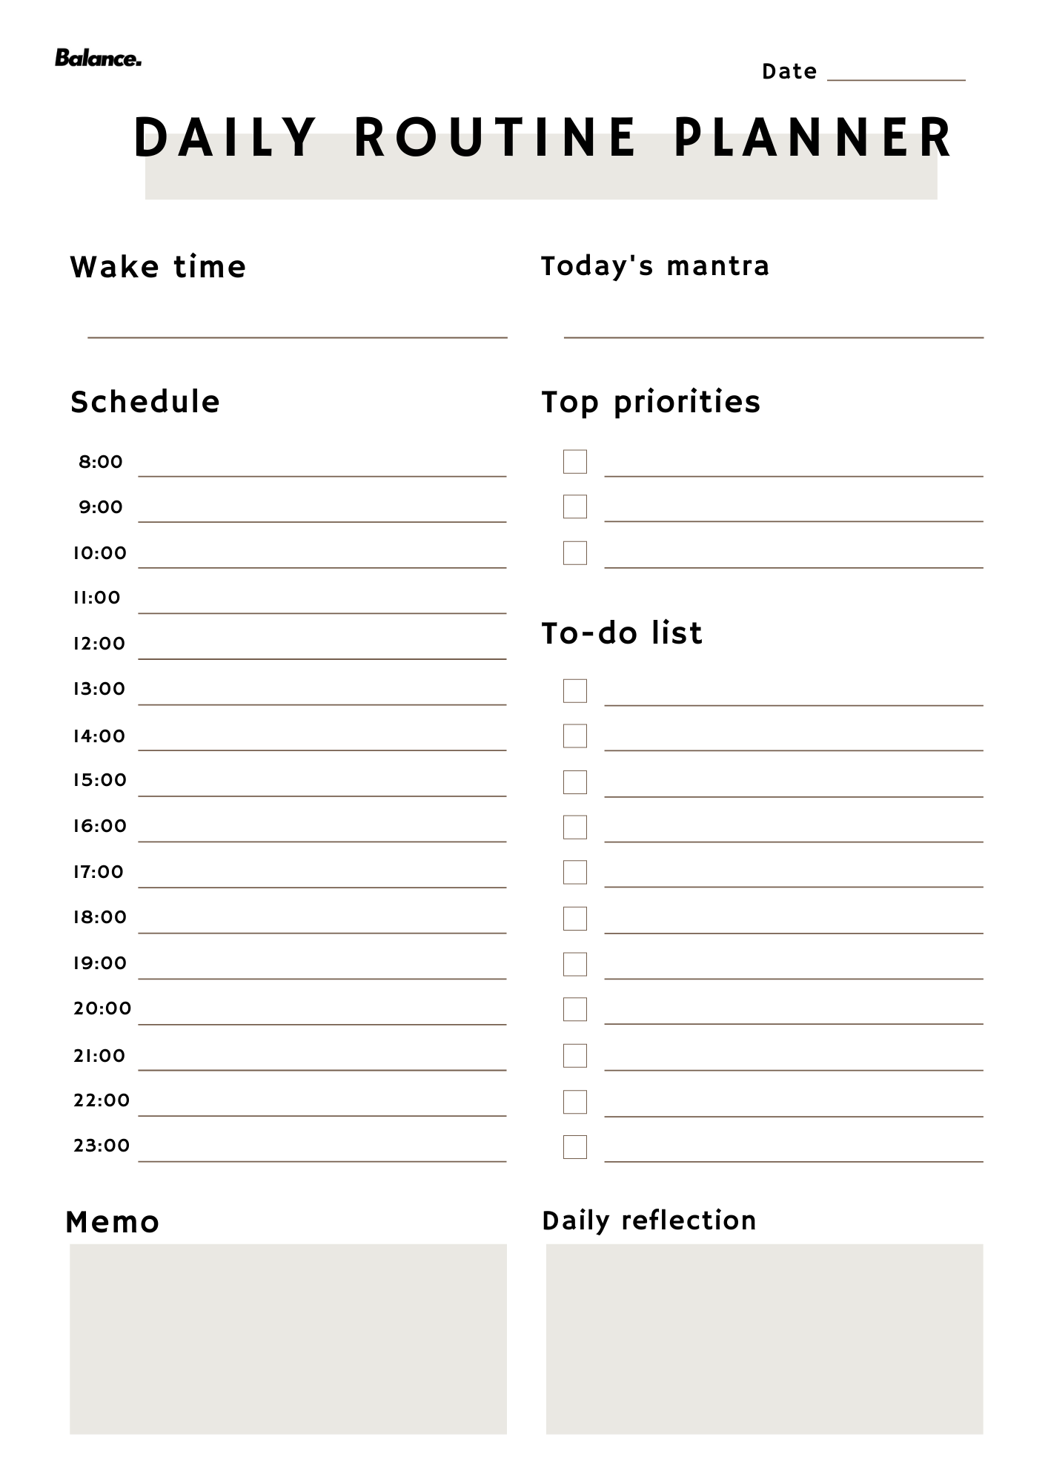

While having a routine is important, give yourself some flexibility and don’t beat yourself up if you have trouble sticking to your own schedule. Everyone copes with stress differently. Having a routine can help you maintain a sense of normalcy and focus through tough times, but don’t stress yourself out more if you sometimes deviate from your plans.

How to develop a routine when you don’t have a set schedule
Developing a healthy routine is challenging in the best of times but it can feel damn-near impossible when you don’t have a set schedule.
If you work varying shift patterns, have education related scheduling demands, have kids or animals to manage with challenging schedules of their own or whatever else it could be, you know that your routine (or lack thereof) differs day on day.
If you want to create a morning routine, night routine – really ANY kind of routine – these tips will help you do that, regardless of your schedule.
Build on your “constants”
Even if you work varying shifts or your schedule changes from week to week, there are some constants in your day-to-day life.
For most of us, those constants are:
- Waking up and going to bed
- Eating
- Brushing our teeth, showering, etc.
- Exercise
- Getting to and from work
- Work itself
Once you identify these daily constants, you can begin to build your routine around them.
You can get up and go for a walk at 6am before breakfast if that’s what you want to do and, on the days, you’re working nightshift (just an example) you can get up a few hours before your shift starts to go on that same walk before having your first meal (equivalent to breakfast) that day.
Build a routine one piece at a time
One of the major problems we see for people trying to establish a routine is that they try to do introduce a brand-new routine all at one time. If you’ve ever tried to change everything in your life, all at once – regular meal times, a fixed bed time, no screens after 7 pm, journaling every night etc. – you know that it simply doesn’t work (or, at least, doesn’t last!).
Humans have a limited amount of self-control and decision-making that we can exert in a given day and trying to build a 100-part routine from nothing is a recipe for disaster and setting you up for failure.

Instead, choose ONE thing you’d like to anchor to a daily constant and start there. After a fortnight or so of doing that consistently, add one more thing.
Examples:
- Regular meal times
- Establishing a sleep routine
- Think about 5 things you’re grateful for while you brush your teeth
- Having a defined cut off point for work
This isn’t to say that you can’t try to incorporate several at these at one time which compliment each other and are fairly simplistic to implement (if you have to honestly rate them out of difficulty of consistent application one a scale of 1 to 10, then having a number of 4 or 5 out of 10 rated habits would be more feasible to implement than several 7, 8 or 9 out of 10 habit changes).
The importance of accountability and support
Did you know…
We’re 65% more likely to achieve a goal – like creating a routine – when we have accountability.
Accountability and support look different for everyone. What works for you depends on your personality, your learning style and the demands on your time.
A few ideas for creating accountability and getting support:
- Communicate, communicate, communicate – support won’t work unless you actively interact with your support network
- Set alarms on your phone to check in with yourself. Every day at noon, or your approximate lunch time, check your phone and check “Did you journal today?”
- If you share a living space with someone, ask them to help to hold you accountable

